Date of publication xxxx 00, 0000, date of current version xxxx 00, 0000.

*Digital Object Identifier 10.1109/ACCESS.2020.DOI*

**Efficient 3-D Near-Field MIMO-SAR**

**Imaging for Irregular Scanning**

**Geometries**

**JOSIAH W. SMITH1 AND MURAT TORLAK1**

1Electrical and Computer Engineering, The University of Texas at Dallas, 800 W. Campbell Rd. Richardson, TX 75080 USA (e-mail: jws160130@utdallas.edu) Corresponding author: Josiah W. Smith (e-mail: josiah.smith@utdallas.edu).

This work was supported by the Semiconductor Research Corporation (SRC) task 2712.029 through The University of Texas at Dallas’ Texas Analog Center of Excellence (TxACE).

 **ABSTRACT** In this article, we introduce a novel algorithm for efficient near-field synthetic aperture radar (SAR) imaging for irregular scanning geometries. With the emergence of fifth-generation (5G) millimeter wave (mmWave) devices, near-field SAR imaging is no longer confined to laboratory environments. Recent advances in positioning technology have attracted significant interest in a diverse set of new applications for mmWave imaging. However, many use cases such as automotive-mounted SAR imaging, unmanned aerial vehicle (UAV) imaging, and freehand imaging with smartphones are constrained to irregular scanning geometries. Whereas traditional near-field SAR imaging systems and quick personnel security (QPS) scanners employ highly precise motion controllers to create ideal synthetic arrays, emerging applications, mentioned previously, inherently cannot achieve such ideal positioning. Additionally, many Internet of Things (IoT) and 5G applications impose strict size and computational complexity limitations that must be considered for edge mmWave imaging technology. In this article, we propose a novel algorithm to leverage the advantages of non-cooperative SAR scanning patterns, small form-factor multiple-input multiple-output (MIMO) radars, and efficient monostatic planar image reconstruction algorithms. We propose a framework to mathematically decompose arbitrary and irregular sampling geometries and a joint solution to mitigate multistatic array imaging artifacts. The proposed algorithm is validated in simulation and through an empirical study of arbitrary scanning scenarios. Our algorithm achieves high-resolution and high-efficiency near-field MIMO-SAR imaging and is an elegant solution to computationally constrained irregularly sampled imaging problems.

 **INDEX TERMS** 5G, automotive SAR, drone mmWave imaging, freehand imaging, handheld scanner, irregular sampling, mmWave imaging, multistatic imaging, real-time imaging, synthetic aperture radar

(SAR)

|  |  |
| --- | --- |
| **I. INTRODUCTION**  Low-cost electromagnetic imaging systems have gained attention over the past decade as commercially available radar platforms have become increasingly affordable. Millimeterwave (mmWave) radar has attracted exceptional interest for applications including gesture recognition [1], concealed threat detection [2], [3], and medical imaging [4], [5] due to its semi-penetrating non-ionizing nature and low power consumption. Additionally, with the emergence of fifth-generation (5G) and sixth-generation (6G) technology, ultra-wideband (UWB) mmWave transceivers are enabling unprecedented sensing and communications feats [6]–[8]. | Small form-factor multiple-input-multiple-output (MIMO) radars are increasing in popularity due to low cost and power consumption [3], [9]. In addition to emerging 5G communications, mmWave radar has already been realized for high-resolution sensing on the Google Pixel 4 [8]. Of particular interest, recent work has enabled freehand mmWave imaging by employing positioning sensors commonly employed in smartphones and virtual reality (VR) sensor suites [7], [10]–[13]. Sub-wavelength localization accuracy was previously unachievable by conventional techniques such as 5G mmWave [14] or Bluetooth low energy (BLE) ranging [15]. Freehand mmWave imaging is a high-resolution imaging |
| VOLUME 4, 2016 | 1 |

technique relying on conventional synthetic aperture radar (SAR) principles [16]–[20] and precise tracking of the handheld radar device as it is moved by a human user throughout space [7], [21]–[23]. Whereas traditional mmWave SAR imaging requires precise motion systems to achieve nearideal synthetic arrays [20], the scanning geometry employed by a freehand imaging system is generally irregular and does not conform to the typical array geometries required for efficient image reconstruction algorithms [24].

While recent work has proposed a fast imaging algorithm for irregular SAR geometries using array linearization [25], the proposed technique adopts a simplistic model of the array displacement and does not explore the near-field multistatic effects, both of which are addressed in this study. However, efficient algorithms for near-field MIMO-SAR operation under irregular scanning geometries are previously unexplored in the literature.

Extensive work on freehand mmWave imaging has been conducted by Laviada *et al.* at the University of Oviedo [7], [10]–[13], [26], [27]. High-precision localization systems to enable freehand SAR imaging have been investigated using an infrared camera network to accurately track the device location across time and recover electromagnetic (EM) images [10]. Their work has been extended to employ an inertial measurement unit (IMU) and depth camera sensors to achieve standalone freehand imaging with promising results [7], [13]. In each of these efforts, the subject attempts to move the hand in a raster pattern to synthesize an approximately rectangular planar aperture with a linear frequency modulated (LFM) handheld radar [7], [10], [11]. Due to the subject’s inability to move their hand in an ideal planar trajectory and the sensitivity of the mmWave signal to submillimeter perturbations, the image is reconstructed using the generalized back-projection algorithm (BPA).

Similar irregular and non-cooperative scanning geometries have been observed in unmanned aerial vehicle (UAV) SAR imaging [26], nonuniform NDT [27], and automotive SAR imaging [28]. However, for many edge and mobile applications, limitations on power consumption and computational complexity cannot be overcome by existing approaches for irregularly sampled SAR. Although image reconstruction algorithms have been thoroughly investigated in the literature for cooperative synthetic array geometries [1], [3], [9], [16]– [20], [24], [29]–[33], widely applicable efficient near-field imaging algorithms for applications such as freehand smartphone imaging, UAV imaging, and automotive SAR imaging have not been thoroughly addressed in the existing literature. Furthermore, while MIMO arrays, commonly employed in commercially available radar devices, offer spatially efficient small array sizes, MIMO-SAR operation introduces a handful of complications to the image reconstruction process and proper handling of the multistatic array is necessary to avoid imaging artifacts [17]. While progress has been made towards projecting MIMO-SAR radar data to virtual singleinput-single-output (SISO) monostatic data [17], [24], the analysis is performed on a coplanar assumption that does not generally hold for irregular scanning geometries.

In this article, we propose a novel image reconstruction technique for efficient near-field imaging with irregular scanning geometries, such as those present in freehand imaging, UAV SAR, or automotive scenarios. We examine the system and signal models for UWB MIMO-SAR and develop a multi-planar multistatic approach to mathematically decompose the irregularly sampled synthetic array such that an equivalent virtual planar monostatic array can be constructed. This technique is the first to extend the range migration algorithm (RMA) such that non-cooperative SAR scanning and multistatic effects are simultaneously mitigated. The analysis in the subsequent sections provides a novel framework through which to decompose irregular SAR scenarios and efficiently project the irregular MIMO-SAR samples to a virtual planar monostatic equivalent. The proposed algorithm is validated through simulation and experimentation, demonstrating robustness to arbitrary scanning patterns and offering low computational complexity. A thorough study of the relationship between array irregularity and image resolution of the proposed algorithm. The proposed technique demonstrates high-fidelity focusing comparable to the traditional planar RMA even under array perturbation on the order of 10s of wavelengths. Our solution enables emerging technologies that require non-ideal SAR scanning geometries, MIMO multistatic radar, and efficient image reconstruction.

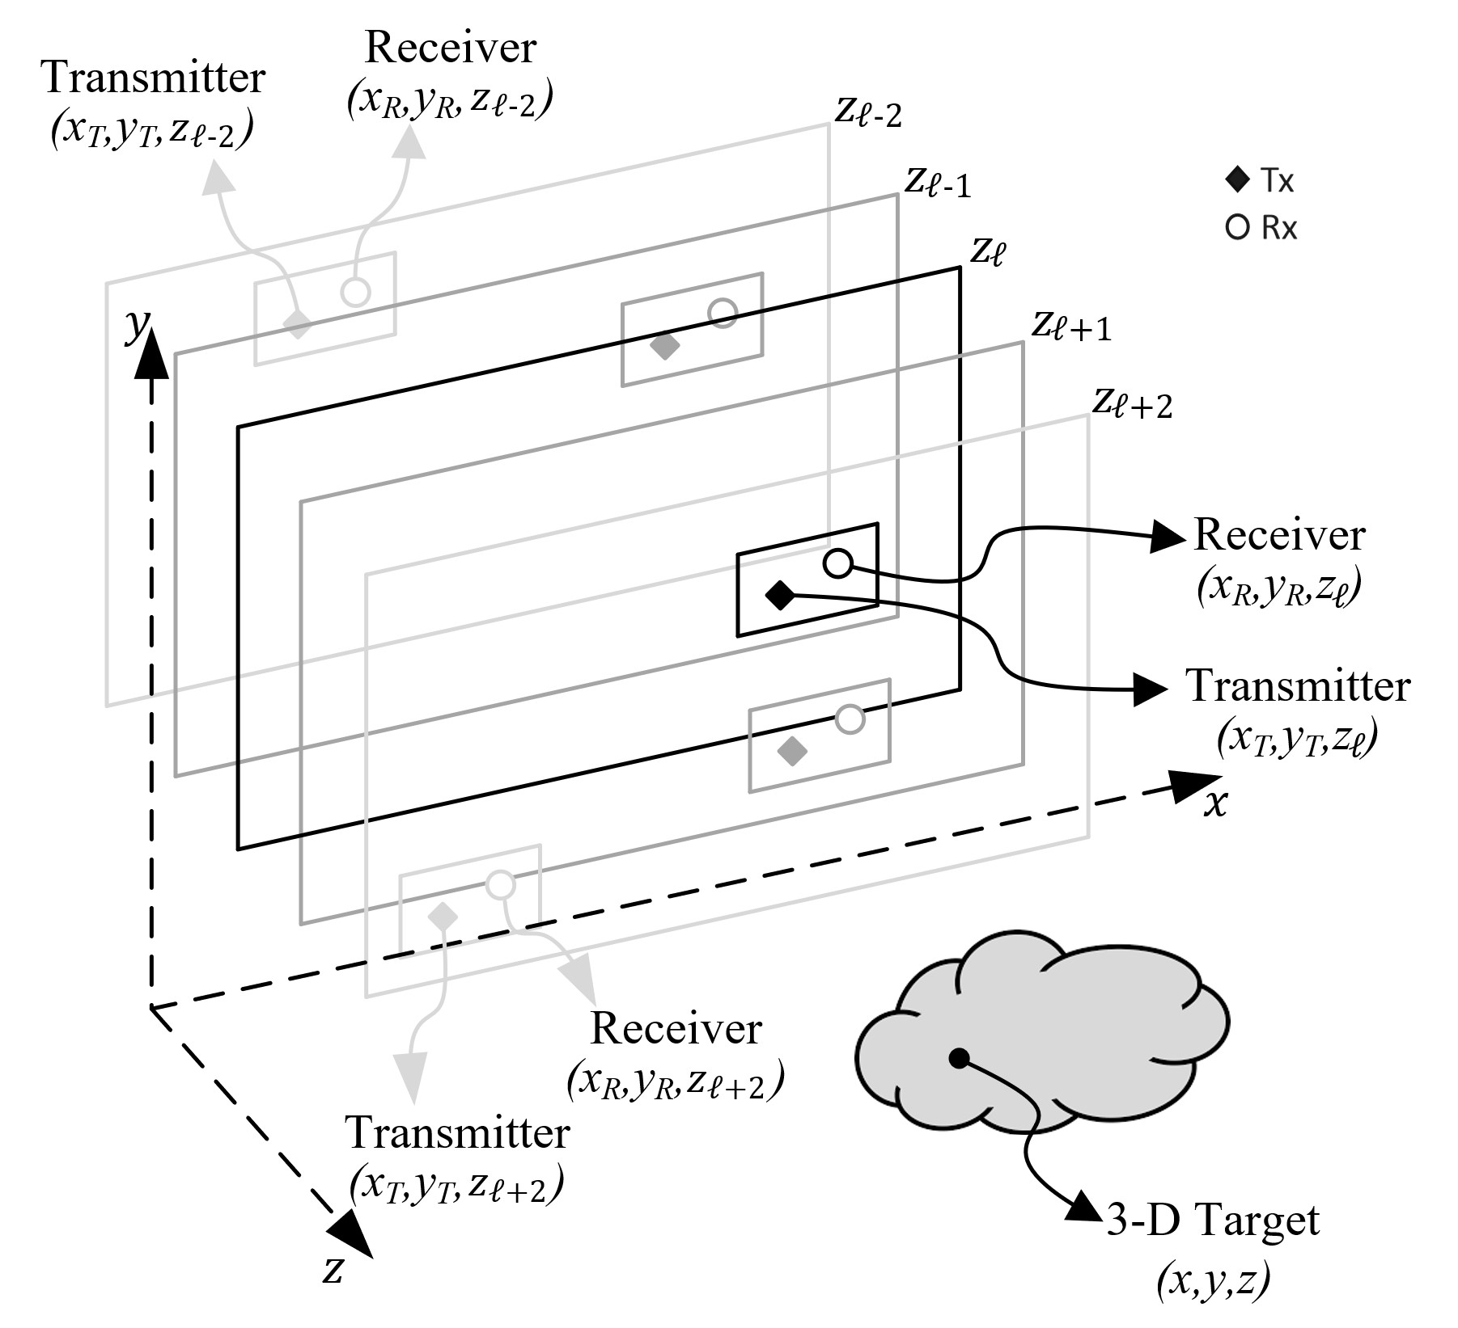

Figure 1: Geometry of the multi-planar SAR irregular scanning geometry with a multistatic array.

The remainder of this paper is organized as follows. Section II introduces the system model, including the multiplanar multistatic SAR concept, signal model, and a novel compensation technique to planar monostatic SAR. In Section III, efficient imaging methods and implementation details are discussed, and an enhanced algorithm is proposed. Section IV details the hardware and software implementation for collecting multi-planar multistatic SAR data. The results from the simulation and empirical studies are presented and discussed in Section V, followed by the conclusions.

# II. SYSTEM MODEL

In this article, we propose the characterization of irregular or arbitrary three-dimensional (3-D) MIMO-SAR sampling geometry using the multi-planar multistatic scenario shown in Fig. 1, where data are collected along different *z*-planes by a MIMO multistatic radar with respect to a stationary 3-D target.

# A. MULTI-PLANAR MIMO-SAR CONFIGURATION

For many SAR applications mentioned in Section I, as the radar is moved throughout 3-D space, it is generally oriented in the same direction towards some target; however, the samples are taken across several *z*-planes. As the data are collected while during an arbitrary SAR scanning path, the resulting synthetic aperture does not conform to the standard scanning regimes, for example, rectilinear/planar [2], [20], circular [27], [32], or cylindrical [16], [24], [33]. Hence, the image reconstruction process must consider the irregularity of the spatial sampling, whose geometry is detailed in Fig. 1.

Compared to planar MIMO-SAR, which requires a multistatic MIMO array to be scanned across a planar track [17], [20], [31], multi-planar MIMO-SAR allows the multistatic array to be scanned across 3-D space. For freehand imaging or automotive SAR, a MIMO array is fixed to the smartphone or vehicle, respectively, and is moved throughout space generating a multi-planar MIMO-SAR irregular aperture. As shown in Fig. 1, as the multistatic array is scanned in an irregular pattern spanning multiple *z*-planes, the locations of the transmit (Tx) and receive (Rx) elements are spatially translated by the movement of the MIMO array. The analyses in the subsequent sections present an efficient solution to irregular MIMO-SAR imaging such that the position of the radar is known throughout the scan and the planar array assumption does not hold. This scenario is common for many of the aforementioned applications, which necessitate both irregular scanning geometries and efficient image recovery.

# B. THE 3-D MULTI-PLANAR VIRTUAL ARRAY RESPONSE IN NEAR-FIELD IMAGING

By the analysis of [17], [24], [34] for the 2-D case, a multistatic MIMO array can be approximated by a monostatic virtual element located at the midpoint of the Tx and Rx elements under the far-field assumption for a small fraction *ϵ* as

q(*d y* 2 ≤ √4*ϵλR,* (1)

*x*)2 + (*dℓ*) *ℓ*

where *dxℓ* , *dyℓ* are the distances between the Tx and Rx elements along the *x*- and *y*-directions, respectively, as shown in Fig. 2, *λ* is the wavelength of the carrier frequency, and *R* is the distance from the midpoint of the antenna elements to a reference point in the scene.

However, under the multi-planar multistatic framework, it is desirable to approximate each Tx/Rx pair by its virtual element located on a *Z*0 plane in the near-field. In this way, multi-planar data can be projected onto a virtual planar array to ease the subsequent image reconstruction process. As shown in Fig. 2, the *ℓ*-th Tx/Rx pair located on the *zℓ* plane can be approximated by the element located at the midpoint between the Tx and Rx elements migrated to the *Z*0 plane.

For near-field SAR, the assumption in (1) is not valid, and the approximation must be handled more delicately. Hence, we derive an efficient compensation algorithm to approximate the multistatic multi-planar array as a monostatic planar array for near-field imaging scenarios.

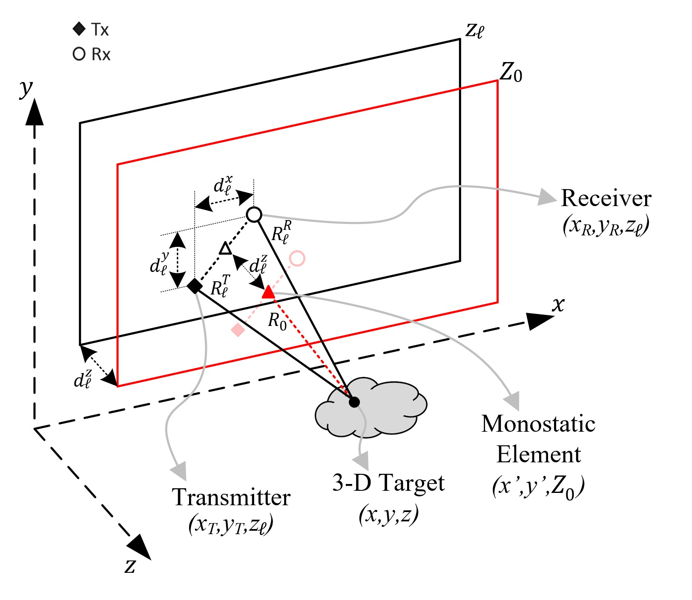

Figure 2: Relationship between the multi-planar multistatic elements and virtual planar monostatic elements.

The transmitter (Tx) and receiver (Rx) of the *ℓ*-th multistatic MIMO array are located at (*xT,yT,zℓ*) and (*xR,yR,zℓ*), respectively, and the target scene is assumed to be a distributed target whose coordinates are given by (*x,y,z*). In this study, orthogonality is leveraged across time by operating the MIMO radar using the time-divisionmultiplexing (TDM) MIMO technique such that each Tx/Rx pair is activated sequentially. The round-trip distance between the *ℓ*-th Tx/Rx pair and the point scatter located at (*x,y,z*) can be written as

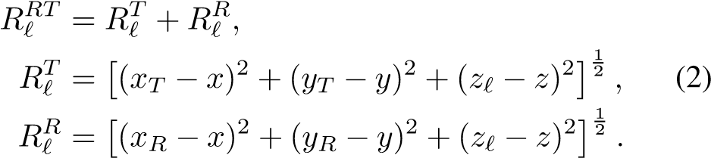

Denoting virtual antenna element locations as (*x*′*,y*′*,Z*0), the *x*- and *y*-coordinates of the Tx/Rx pair can be expressed as

|  |  |  |
| --- | --- | --- |
| *xT* = *x*′ − *dxℓ /*2*, xR* = *x*′ + *dxℓ /*2*,* | *yT* = *y*′ − *dyℓ/*2*, yR* = *y*′ + *dyℓ/*2*.* | (3) |

Similarly, denoting *dzℓ* as the distance between the *Z*0 plane and the *zℓ* plane, as shown in Fig. 2, the *z*-coordinate of the Tx and Rx elements can be expressed with respect to

*Z*0 as

*zℓ* = *Z*0 + *dzℓ.* (4)

As described in Appendix A, substituting (3) and (4) into (2) and applying the third order Taylor series expansion of *Rℓ* for small values of, and yields

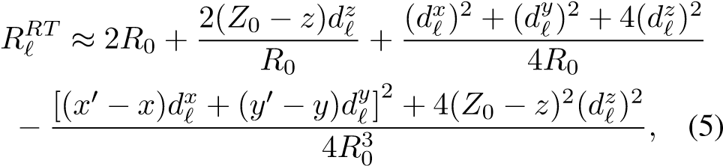

where *R*0 is the distance between the virtual monostatic element located at (*x*′*,y*′*,Z*0) and the point scatterer at (*x,y,z*), expressed as

 *.* (6)

Centering the target to the origin of the (*x,y,z*) coordinate system and considering (*x*′ − *x*)*,*(*y*′ − *y*) ≪ *Z*0, we can acquire the improved approximation of the round-trip distance between the *ℓ*-th Tx/Rx pair and the point scatterer as

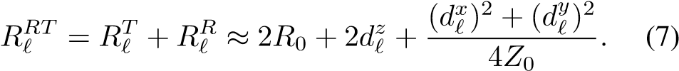

## *C. SIGNAL MODEL*

Consider the multi-planar multistatic array whose Tx and

Rx elements are located at (*xT,yT,zℓ*) and (*xR,yR,zℓ*), respectively, and a distributed target occupying the volume *V* at locations (*x,y,z*) in 3-D space with a continuous reflectivity function given by *o*(*x,y,z*). Without loss of generality, under the Born approximation for the scattering process and an isotropic antenna assumption, the received signal can be written as

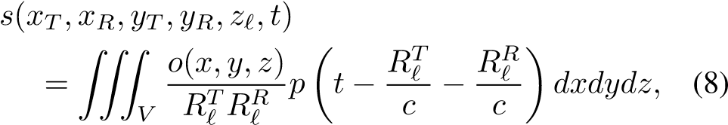

where *p*(*t*) is the transmitted signal, *t* is the fast-time variable, *c* is the speed of the EM wave, and *RℓT*, *RℓR* are given in (2).

The Fourier transform of (8) with respect to *t* yields the frequency spectrum as

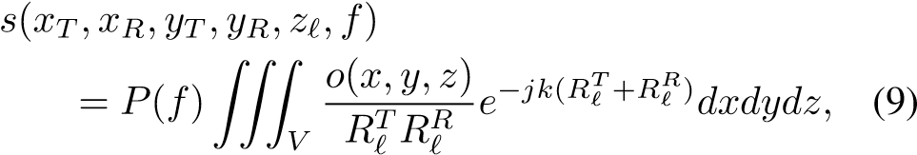

where *k* = 2*πf/c* is the instantaneous wavenumber and *P*(*f*) is the Fourier transform of *p*(*t*). Image recovery requires the inversion of (9) to produce *o*(*x,y,z*); however, given the arbitrary sampling locations, the image cannot be computed efficiently using existing techniques [7], [10]–[13], [26], [27]. The frequency-domain model of the received signal (9) is valid for any UWB radar signaling scheme, including frequency-modulated continuous-wave (FMCW), phase modulated continuous wave (PMCW), or orthogonal frequency-division multiplexing (OFDM), commonly employed in 5G and IoT applications [35]. Further, prior research on freehand imaging and similar IoT applications has employed a purely stepped-frequency, FMCW signal model [10]–[13]. Similarly, the Google Pixel 4 utilizes a Google Soli 60 GHz mmWave FMCW radar for sensing [8].

However, the derivation of (7) enables efficient compensation of multistatic multi-planar data by careful handling of the phase. To achieve the proposed compensation, we express the frequency response to the virtual planar monostatic array, whose elements are located at (*x*′*,y*′*,Z*0), as

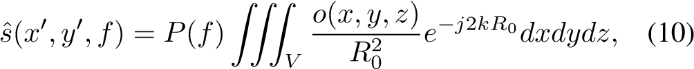

where *R*0 is given by (6); *x*′ and *y*′ are the midpoints between each Tx/Rx pair; and *Z*0 is the plane onto which the samples are projected. From the analysis in Section II-B, the relationship between the multi-planar multistatic response and virtual monostatic array response is given by *s*ˆ(*x*′*,y*′*,f*) ≈ *s*(*xT,xR,yT,yR,zℓ,f*)*ejkβℓ,* (11)

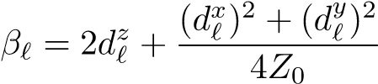where

*,* (12)

is the near-field residual phase term due to the arbitrary scanning and MIMO effects in the near-field, as derived in (7). Hence, the virtual planar monostatic response can be efficiently acquired from the irregular samples by removing the residual phase to simultaneously account for multi-planar scanning geometry and near-field multistatic effects. The novel phase compensation technique derived in this section efficiently reduces the dimensionality of the MIMO-SAR imaging problem and projects multi-planar samples onto a single plane to enable computationally tractable algorithms for image reconstruction.

## III. EFFICIENT IMAGE RECONSTRUCTION

### ALGORITHMS FOR NEAR-FIELD SAR

In this section, we review the traditional planar SAR image reconstruction methods using efficient Fourier-based solutions to recover EM images [24] and propose a novel technique for multi-planar multistatic SAR. Existing research on irregularly sampled SAR imaging problems employs the gold standard back-projection algorithm (BPA) [7], [10]–[13], [26], [27]. However, this approach is computationally infeasible for many edge and mobile applications. To overcome this challenge, we employ the approximation in (11) to project multi-planar data to a planar-sampled scenario to satisfy the requirements for efficient image reconstruction. The Fourierbased algorithm detailed in the subsequent analysis is known as the range migration algorithm (RMA) or *f*-*k* algorithm and has been explored in greater detail elsewhere [18], [24], [29]–[31].

The key step to efficiently invert the integral in (10) is to represent the spherical wave term as a superposition of plane waves by the method of stationary phase (MSP) [17], [24], such that

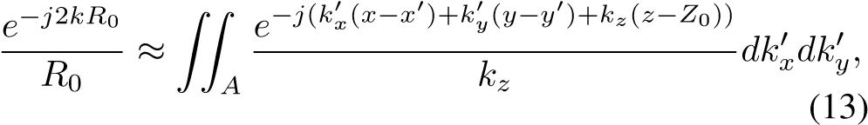

where

*,* (14)

and *A* is the region inspace occupied by the spherical wavefront.

Following the analysis in [20], [24], substituting (13) into (10) and rearranging the phase terms to leverage the Fourier relationships yields

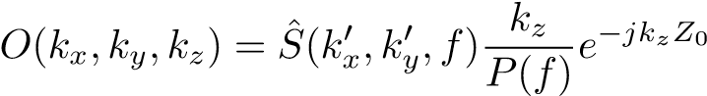*,* (15)

where *O*(*kx,ky,kz*) and are the spatial spectral representations of the reflectivity function *o*(·) and array response *s*ˆ(·), respectively. Since the primed and unprimed coordinate systems are coincident, the distinction can be dropped for the remaining analysis. Hence, the RMA image recovery process can be summarized as *o*(*x,y,z*) = IFT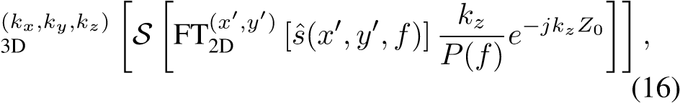

where FT[·] and IFT[·] are the forward and inverse Fourier transform operators, respectively, S is the Stolt interpolation operator required to compensate for the spherical wavefront [24], and *s*ˆ(·) is obtained from (11). The spatial resolution along each dimension of the recovered image is given by

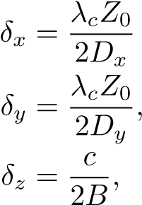*,*

(17)

where *Dx* and *Dy* are the size of the aperture along the *x*- and *y*-directions, respectively, *B* is the system bandwidth, and *λc* is the wavelength of the center frequency [17], [24], [30].

While (16) provides an efficient solution for planar array imaging problems, its application to irregular scanning geometries requires discussion of several key issues. Applying the compensation technique in (11) for irregularly sampled data, the multi-planar data can be approximately projected to planar sampling; however, they are likely non-uniform at the positions (*x*′*,y*′*,Z*0) along the *x*- and *y*-directions. Traditional efficient implementations rely on the common fast Fourier transform (FFT) algorithm, but recent work on non-uniform planar MIMO-SAR [30], [31] and irregular MIMO real aperture radar (MIMO-RAR) [36] imaging has produced solutions using a non-uniform FFT (NUFFT) approach employing fast Gaussian gridding (FGG) discussed in [37] for the Fourier transforms and Stolt interpolation step in (16). The sampling criteria for the nonuniform planar case are discussed in detail in [30], [31], [36] and apply correspondingly to irregular scanning scenarios after multiplanar compensation. Similarly, the FGG-NUFFT technique is employed in this study to efficiently perform the RMA on irregularly sampled planar data.

For the multi-planar sampling scenario discussed in Section II-A, the RMA cannot be applied directly without multiplanar compensation because the data are sampled on different *z*-planes, as discussed in Section V. If the RMA is applied to the raw multi-planar data, the forward Fourier transform in (16) is invalid because the data along the *x*′ and *y*′-directions are not coplanar and the resulting image will suffer from significant distortion, in most cases rendering the resulting images unusable.

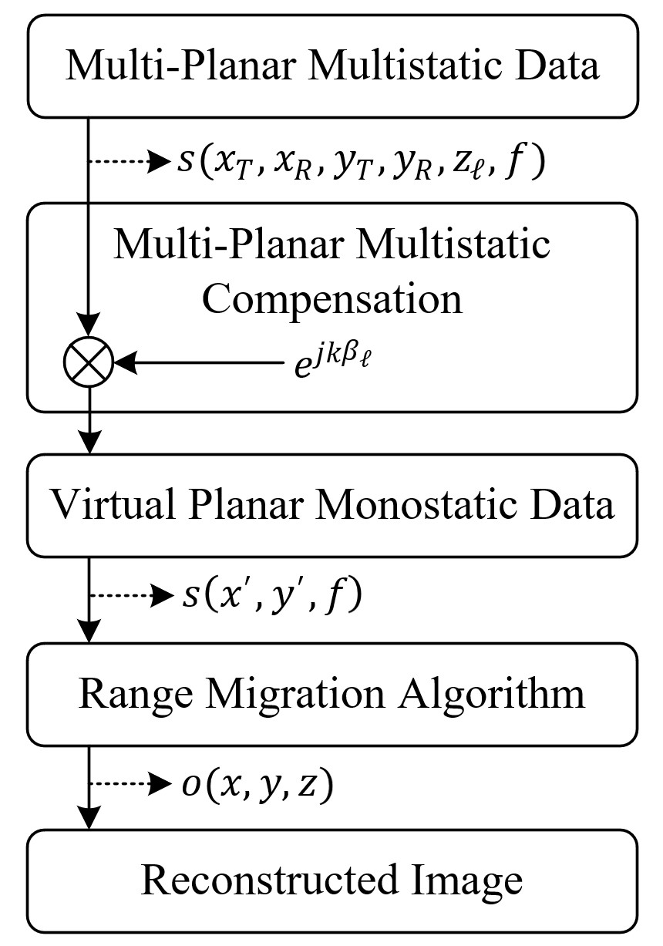

Figure 3: The complete image reconstruction process from irregular sampling compensation to RMA image recovery.

|  |
| --- |
| Figure 4: System design for 3-D scanner with radar mounted on planar *x*-*y* rails and target mounted on a linear *z* rail. The TI radar, data capture card, and mechanical scanner are controlled by MATLAB via USB serial interface. |

Sampling considerations for image reconstruction remain identical to those in analyses elsewhere [17], [29], after the multi-planar compensation algorithm. Baseband frequency sampling criteria can be determined by the maximum range for a given application. As given in [38], the maximum frequency sampling interval is given by ∆*f < c/*(2*R*max), where *R*max is the maximum target range. While spatial sampling criteria are not guaranteed for irregular SAR scanning if the relationship between the capture rate of the radar and the velocity of the radar platform is tuned appropriately during system design, undersampling artifacts are minimal in most cases [10]–[13]. To avoid spatial undersampling, the lower bound of the pulse repetition frequency (PRF) can be computed by PRF *>* 4*v*max*/λc*, where *v*max is the maximum velocity for a certain application. For example, assuming the maximum velocity of a human hand for a freehand SAR is 1 m/s and a center frequency of 79 GHz, the lower bound of the PRF is approximately 1.06 kHz. It is important to note that the number of captures increases proportionally to the PRF; hence, at high velocities, a large number of samples will be captured. Computational performance of traditional techniques, employing the BPA, degrades substantially when many samples are captured. On the other hand, signal-tonoise ratio can be improved by increasing the number of samples, at the cost of increased computational burden. Hence, an efficient algorithm for multi-planar MIMO-SAR imaging is required to enable many such technologies.

In terms of computational complexity, our proposed algorithm offers a significant advantage over existing techniques in the literature [7], [10]–[13], [26], [27], which employ the BPA, whose computational complexity is on the order of *O*(*N*6) [20], [31]. The time complexity of the RMA and its FGG-NUFFT variants are investigated in the literature [31], [36] and the multi-planar compensation step proposed in this article presents negligible computational expense to the RMA, which is on the order of *O*(*N*3 log*N*) [19], [29]. Hence, as discussed in Section V, the algorithm proposed in this article offers comparable imaging performance to the BPA with tractable execution time for mobile platforms similar to the RMA.

The novel enhanced reconstruction process for efficient near-field SAR imaging with irregular scanning geometries is summarized in Fig. 3. Using the analysis in Section II, irregular scanning geometries can be modeled as multi-planar sampling scenarios, as shown in Fig. 1, and compensated by removing the residual phase due to the multi-planar multistatic conditions. The key difference between the traditional RMA and the proposed algorithm is the aligning of the multi-planar multistatic (MIMO-SAR) data to virtual planar monostatic data. This crucial step compensates for both the sampling irregularities and multistatic MIMO effects simultaneously, while significantly reducing the dimensionality, from 6-D (*xT,xR,yT,yR,zℓ,f*) to 3-D (*x*′*,y*′*,f*), and subsequently computational complexity. Subsequently, virtual planar monostatic data are used to recover the image efficiently using the RMA. In simulation and empirical studies on irregular SAR scanning geometries, the proposed algorithm is applied to efficiently produce high-resolution 3-D images previously infeasible due to algorithmic deficiencies.

## IV. MULTI-PLANAR MULTISTATIC IMAGING HARDWARE

### PROTOTYPE

In this section, we discuss the hardware prototype implementation for empirically validating the proposed imaging algorithm by collecting multi-planar multistatic SAR data. The hardware architecture of the mmWave imaging system is detailed in Fig. 4. A Texas Instruments (TI) mmWave MIMO radar is mounted on an *x*-*y* planar scanner. The TI AWR1443BOOST radar with 4 GHz bandwidth from 77 GHz to 81 GHz is mounted to a TI mmWave-Devpack and TSW1400 data capture card to store the data from the SAR scan and transfer it to the PC where the image recovery algorithm is implemented in MATLAB. The TI AWR1443BOOST is equipped with a MIMO array consisting of two Tx elements spaced by 2*λc* and four Rx elements spaced by *λc/*2 [17]. While 5G and IoT applications commonly employ an OFDM modulation scheme, the TI radar employed for the following experiments is limited to FMCW signaling. On the other hand, FMCW radar has been utilized for smartphone applications, notably the Google Pixel 4, which is equipped with a Google Soli FMCW radar [8]. The proposed range migration-based algorithm is applicable to both OFDM and FMCW radars; Hence, the results discussed in the following section are relevant for a wide array of 5G, IoT, smartphone, and automotive applications [39].

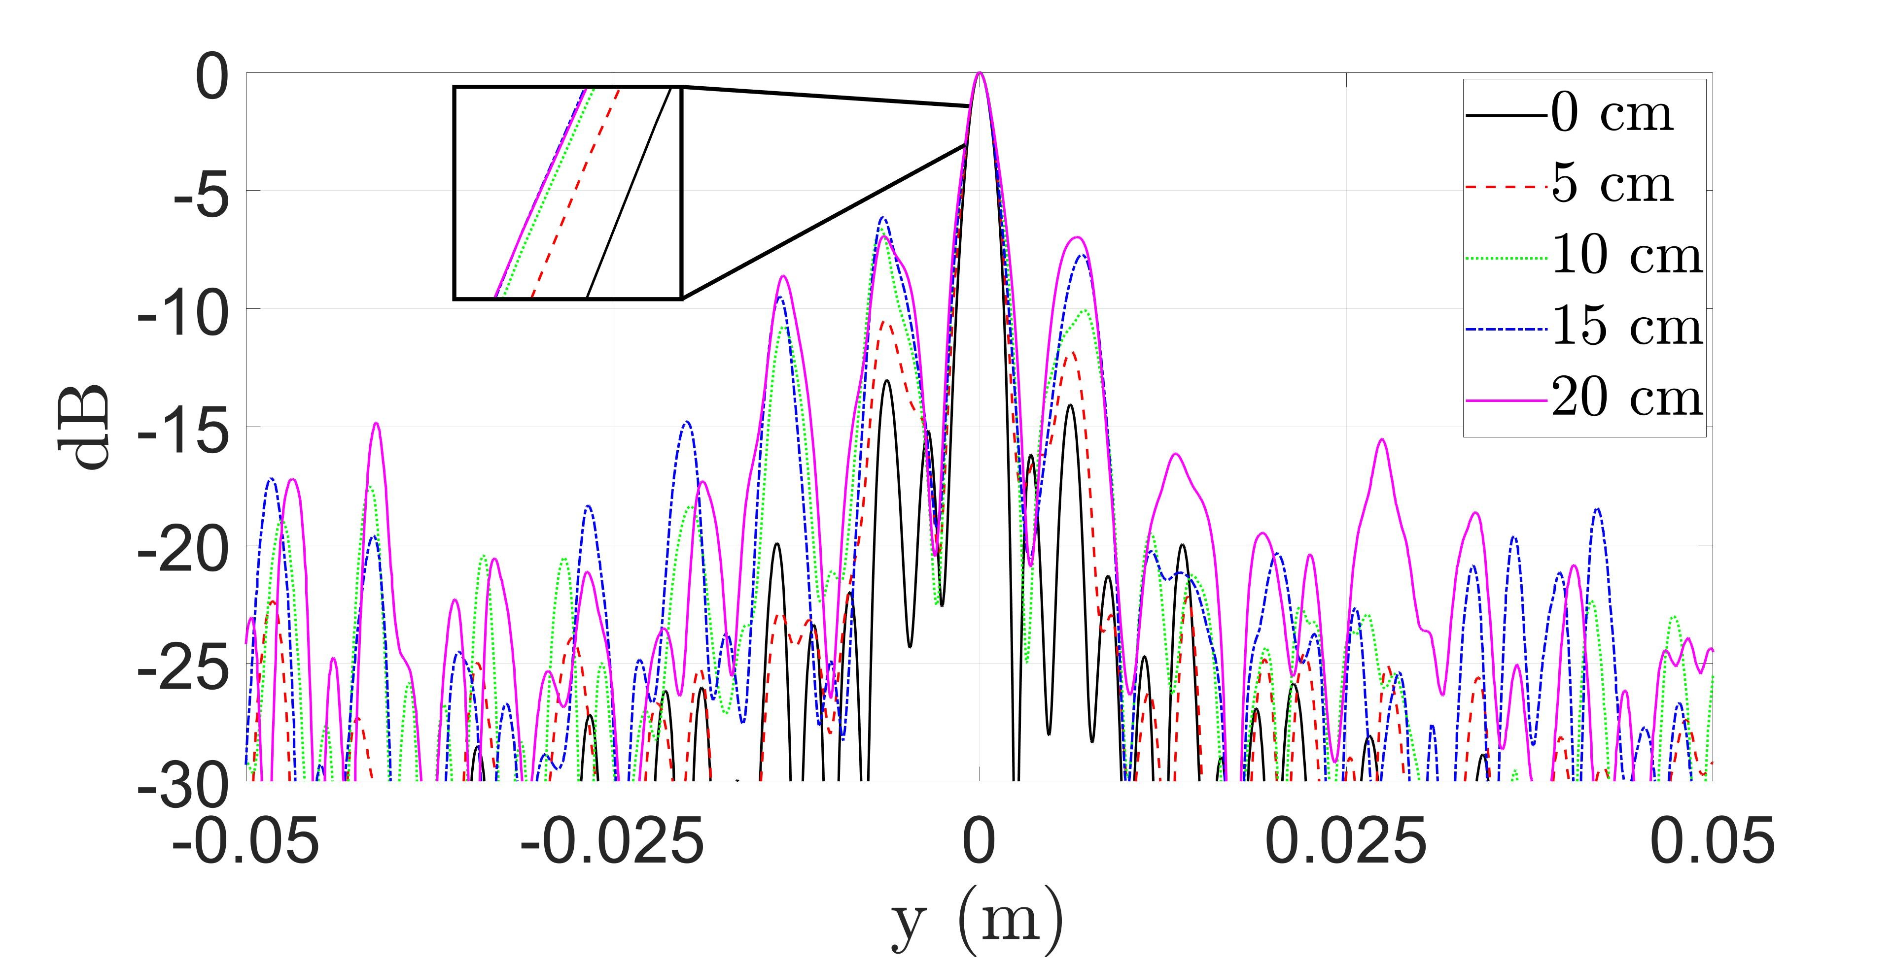

(a)

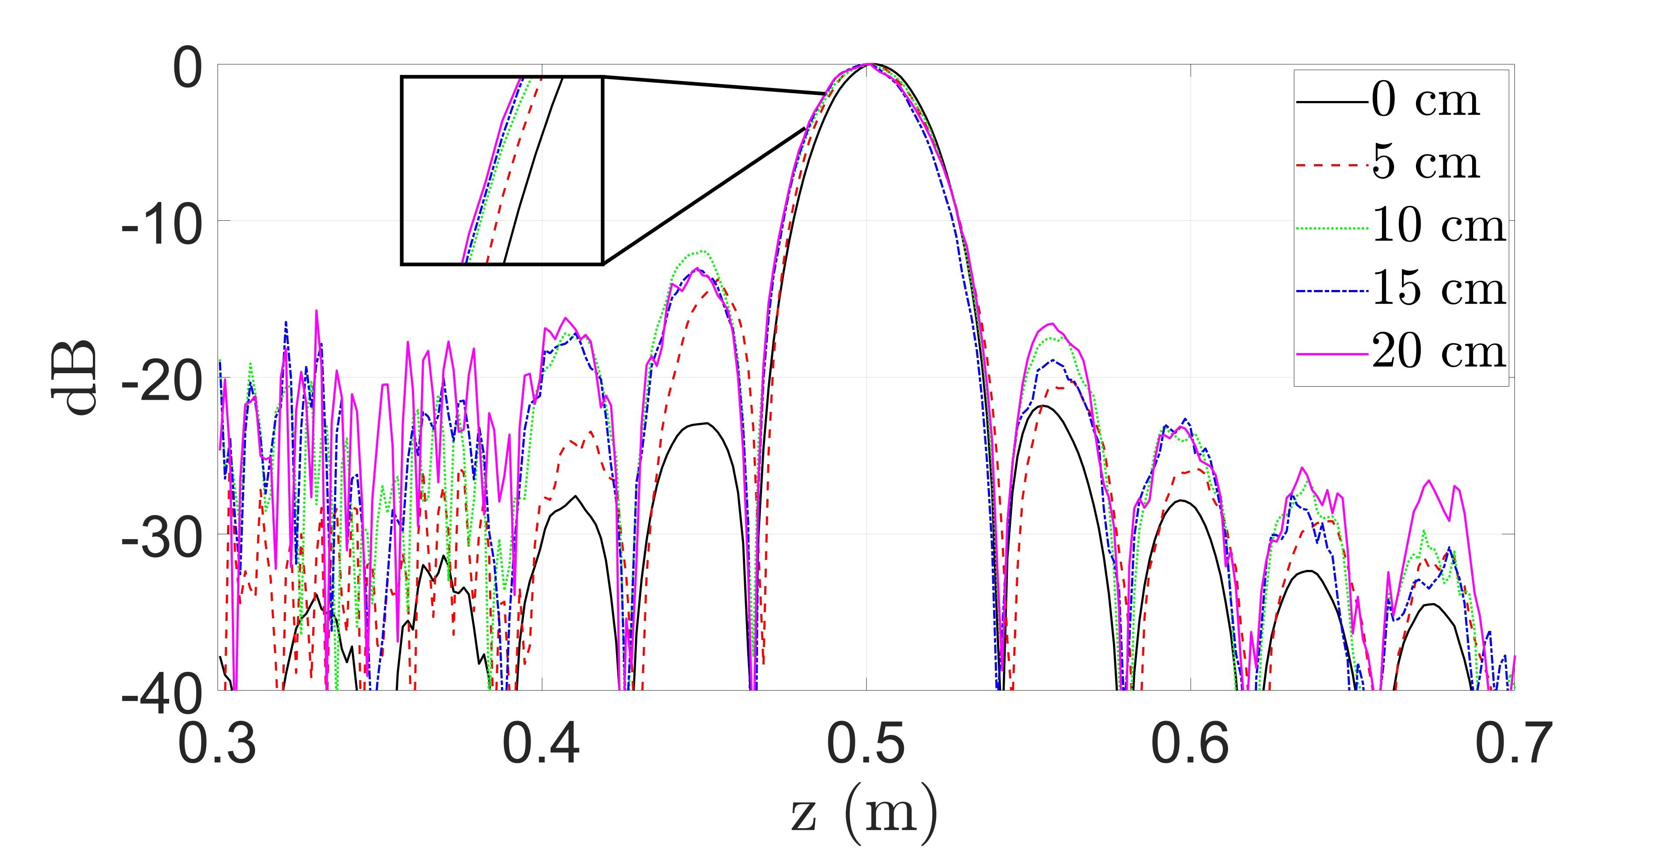

(b)

Figure 5: Comparison of point spread function (PSF) resolution along the (a) *y*- and (b) *z*-direction with varying maximum distance from the reference plane, *Z*0, to the samples at *zℓ*. The distance between the samples and reference plane, ∆max*z* , is varied from 0 cm (linear) to 20 cm with a step size of 5 cm. The linear case (0 cm) is computed with the conventional RMA. Each of the remaining PSFs are computed using our proposed algorithm.

Additionally, a linear rail is used to move the target along the *z*-direction to collect multi-planar multistatic data under the geometry discussed in Section II-A. All three *x*-*y*-*z* rails are driven by stepper motors controlled by an AMC4030 motion controller, and the scanning process and radar set up are handled in MATLAB. Additional details on system development and device calibration can be found in [20]. The images are reconstructed using MATLAB implementations running on a desktop PC equipped with a 12-core AMD Ryzen 9 3900X running at 4.6 GHz with 64 GB of memory. Using this hardware prototype, data can be collected for many target scenarios under the multi-planar multistatic scenario by performing multiple planar SAR scans with the target at different *z*-locations. To emulate irregular scanning geometries, the data collected throughout *x*-*y*-*z* space are subsampled, as discussed in Section V. Implementations in the literature employ multi-camera infrared camera systems to track the radar as it is moved through space by the user [10], [11]. Other studies on irregular scanning geometries have explored freehand imaging using a stereo camera with an IMU for positioning estimation [7] and UAV near-field imaging with a laser rangefinder and real-time kinematic (RTK) system for localization [26]. These implementations, among others [12], [13], [27], [28], demonstrate the viability of high-resolution sensors for precise positioning to enable novel imaging techniques using UWB mmWave radar. Hence, this study focuses on improving the computational efficiency of the imaging technique and assumes that the position of the radar is known across the irregularly sampled geometry.

## V. MEASUREMENT AND IMAGING RESULTS

In this section, we validate the proposed algorithm derived in Sections II and III, and shown in Fig. 3. Irregular scanning geometries are simulated using the simulation platform developed in [24], and image reconstruction results are shown comparing our enhanced method to the gold standard BPA and RMA without multi-planar multistatic compensation. Similarly, using the 3-D mechanical system detailed in Fig. 4, irregular scanning geometries are emulated by collecting planar scans with the target at different *z*-locations and subsampling the collected data. Imaging results are provided comparing the proposed algorithm against the BPA and RMA, demonstrating the computational advantage of our technique. The proposed multi-planar multistatic compensation algorithm achieves image quality comparable to that of the BPA while offering time and space complexity on par with the RMA.

# A. SIMULATED SAR IMAGING RESULTS

To validate our proposed algorithm in simulation, we consider three distinct scenarios. First, we investigate the impact of the array irregularity on image resolution. We consider the point spread functions (PSFs) for several multi-planar MIMO-SAR scenarios compared with an ideal planar scanning scenario to analyze the range and cross-range resolution of the proposed algorithm. We assume a single, ideal point target located at (0*,*0*,*0*.*5 m) in 3-D space for PSF simulation. For comparison, an ideal, linear MIMO-SAR pattern is generated along with several irregular SAR scanning patterns of increasing irregularity. Each non-cooperative motion track is generated by a semi-smooth, random curve spanning *y*′ ∈ [−12*.*5*,*12*.*5] cm with varying *zℓ* around *Z*0 = 0 m with 256 sampling locations, as shown in Fig. 6a. To analyze the impact of *dzℓ* = *zℓ* − *Z*0, the distance between the reference

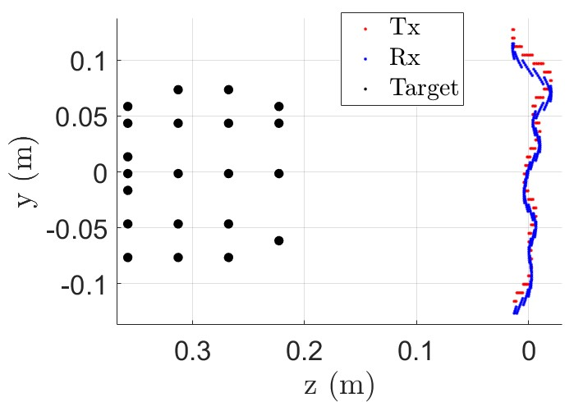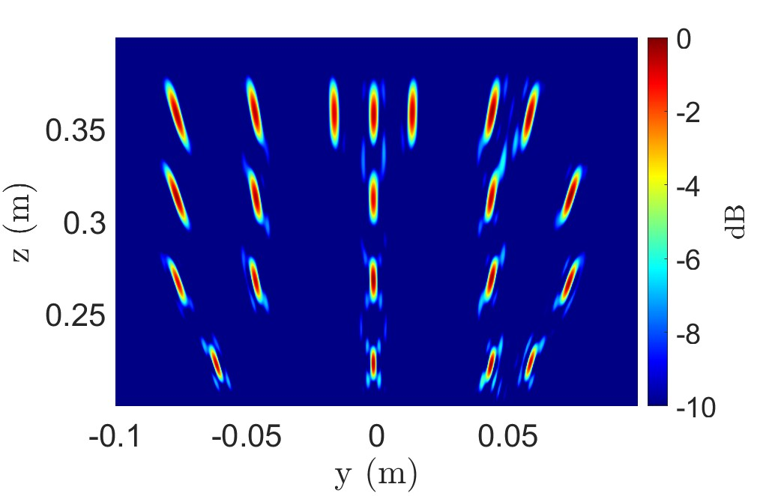

(a) (b)

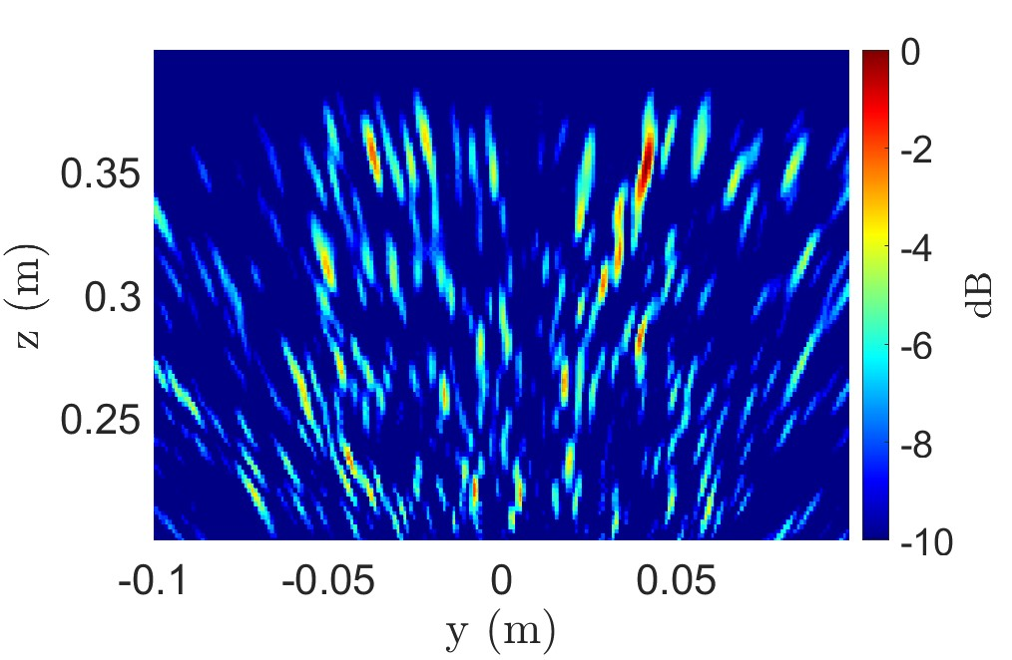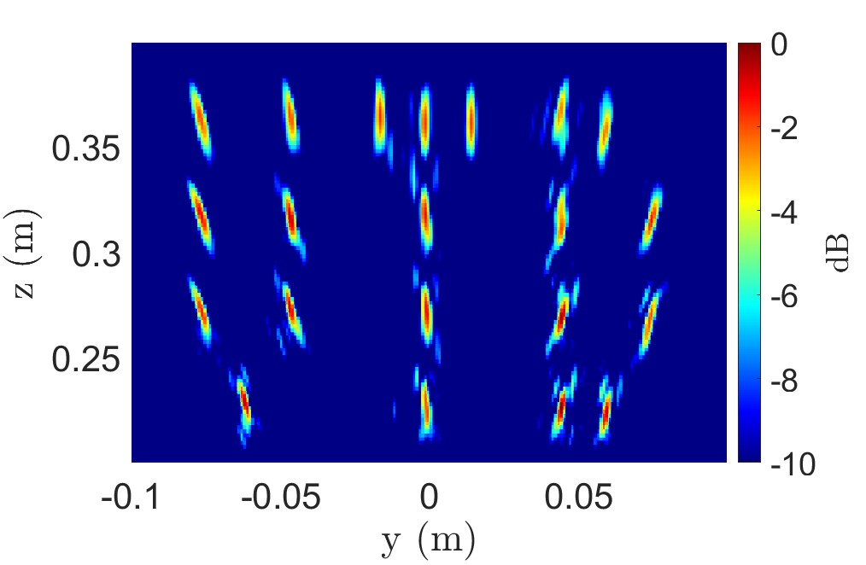

(c) (d)

Figure 6: (a) Irregular scanning geometry for “UTD” scenario consisting of a multi-linear array in the *y*-direction at *x* = 0 m and corresponding imaging results using the (b) BPA (296.3 s), (c) RMA without multi-planar multistatic compensation (29 ms), and (d) our proposed algorithm (30 ms).

plane at *Z*0, and the samples at *zℓ*, we simulate several multiplanar multistatic with increasing variance of *dzℓ*, as shown in Fig. 5. The absolute maximum distance, ∆max*z* ≜ max|*dzℓ*|, varies from 0 cm, the linear case, to 20 cm with a step size of 5 cm. At 79 GHz center frequency, ∆max*z* = 20 cm is more than 50 times the wavelength, *λc* = 3.79 mm. Prior work on freehand smartphone imaging system design assumes deviations on the order of 1 cm [7]. Along the cross-range dimension, symmetric along both the *x*- and *y*-directions, the resolution is minimally affected by the irregular scanning geometry when the algorithm is applied, as shown in Fig. 5a. However, a direct relationship between  and the main beamwidth is observed along with decreased sidelobe suppression compared to the ideal linear case, where the traditional RMA can be employed directly. Along the *z*direction, the resolution of the proposed algorithm suffers as  increases, but remains quite similar to the resolution of the linear case, as shown in Fig. 5b. Hence, our efficient algorithm achieves similar focusing performance to the ideal linear, or planar, RMA case while allowing for irregular scanning geometries with large deviations from the reference plane in the *z*-direction.

To evaluate the performance of the algorithm for more complex targets, a linear array along the *y*-axis is simulated as shown in Fig. 6a with 21 point scatterers arranged as the letters “UTD.” Again, irregular array locations are generated by a semi-smooth, random curve spanning *y*′ ∈ [−12*.*5*,*12*.*5] cm and *zℓ* ∈ [−2*.*5*,*2*.*5] cm with 256 sampling locations. As shown in Fig. 6b, the gold standard BPA recovers each point scatterer without artifacts; however, computing the BPA image requires 296.3 s on our machine.

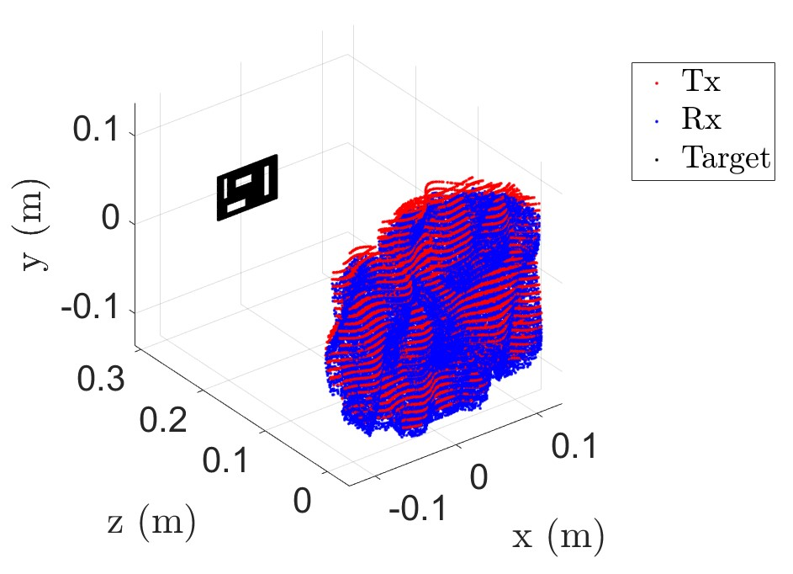

Figure 7: Irregular scanning geometry for cutout consisting of a multi-planar array along the *x*- and *y*-directions.

The RMA without multi-planar multistatic compensation and the proposed algorithm are considerably more efficient, requiring only 30 ms for computation. However, while the RMA image in Fig. 6c is significantly distorted and the image is lost, our proposed method resolves the point targets comparably to the BPA and requires a fraction of the computation time.

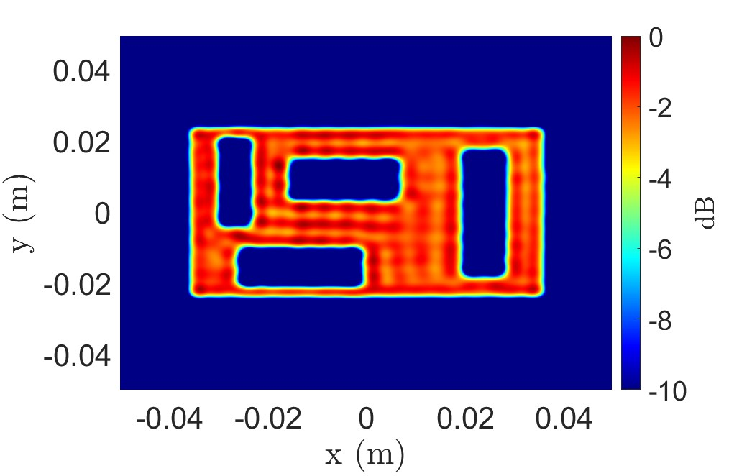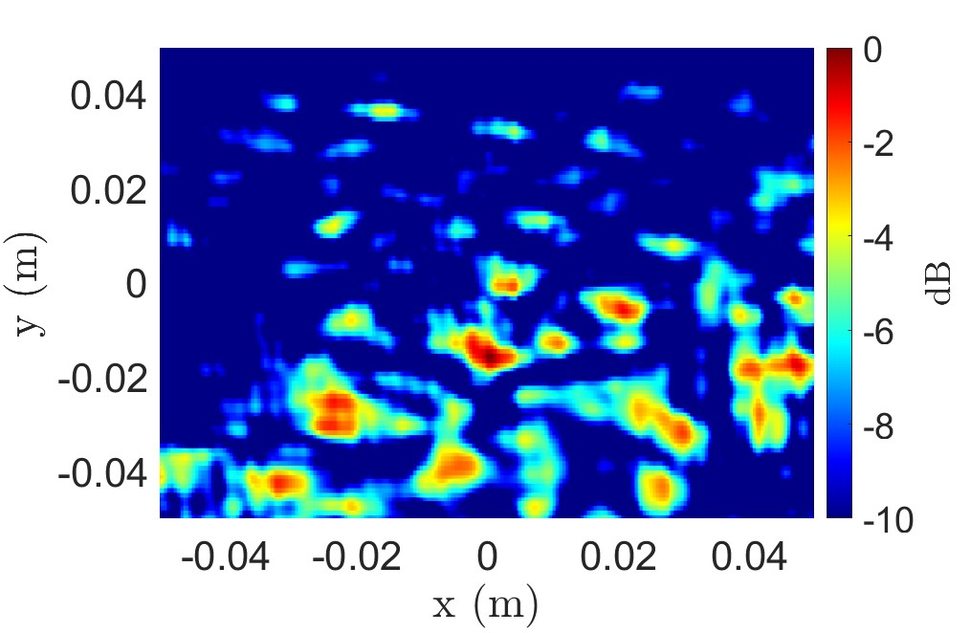

(a) (b)

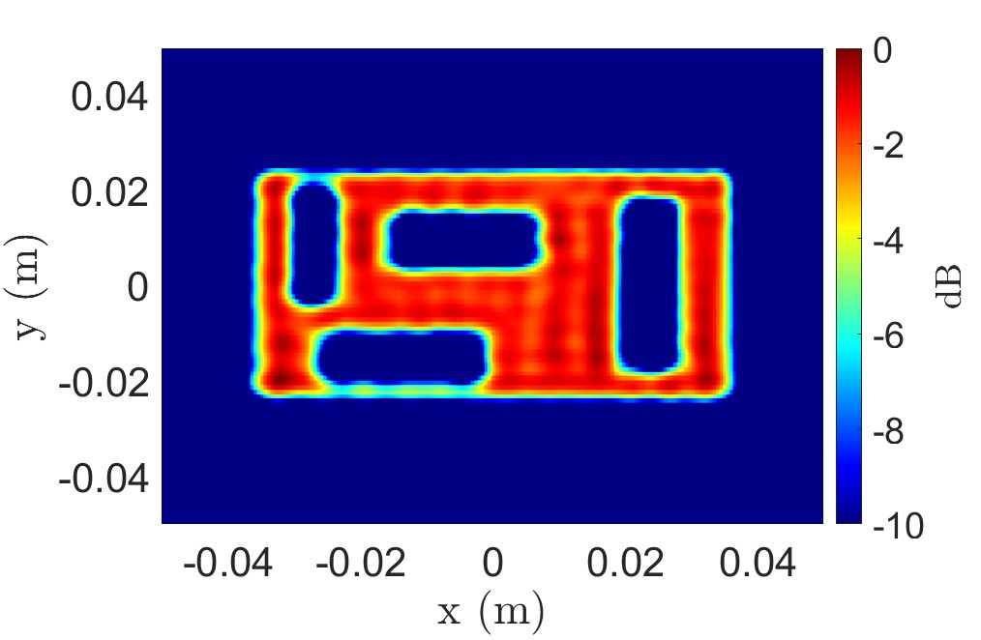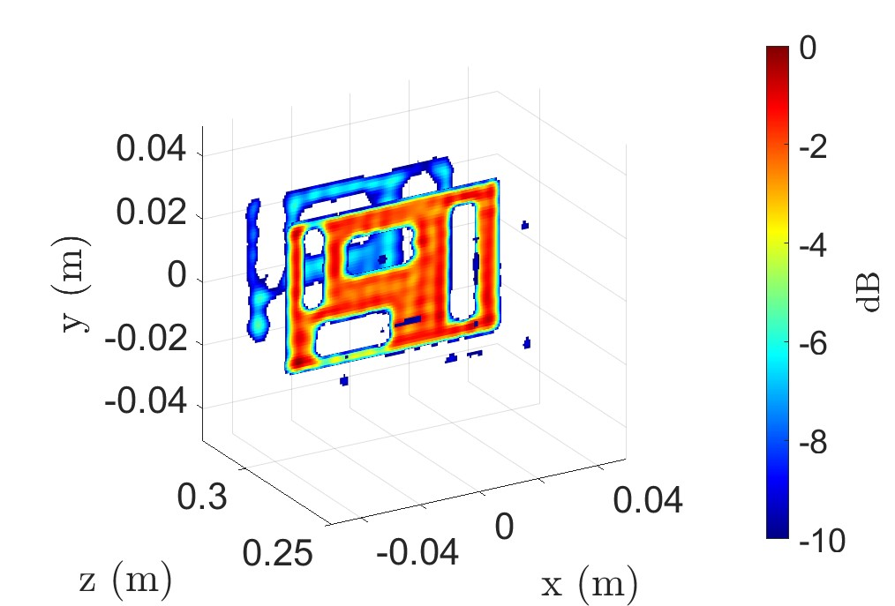

(c) (d)

Figure 8: Imaging results for the scenario in Fig. 7 using the (a) BPA (1324.8 s), (b) RMA without multi-planar multistatic compensation (1.1 s), (c) proposed algorithm at the *z* = 300 mm plane (1.1 s), and (d) the 3-D reconstructed image using the proposed technique (4.8 s).

Considering the more broadly applicable 2-D scanning case, a 2-D multi-planar multistatic scenario is simulated with a solid target located at *z* = 300 mm, as shown in Fig. 7. The target is a rectangular strip with cutouts of various sizes and the irregular sampling geometry is generated as a 2-D semi-smooth random curve occupying *x*′ ∈ [−12*.*5*,*12*.*5] cm, *y*′ ∈ [−12*.*5*,*12*.*5] cm, and *zℓ* ∈ [−2*.*5*,*2*.*5] cm with 102956 sampling locations. Since the target is located on a single *z*-plane parallel to the planar projection after our compensation technique, a 2-D *x*-*y* image is recovered at *z* = 300 mm. Again, while the BPA yields a robust reconstruction, the computation time is excessive for most applications, requiring 1324.8 s on a desktop machine. On the other hand, the proposed algorithm outperforms the RMA significantly in terms of image quality, nearly matching that of the BPA with only slight artifacting, while demonstrating superior efficiency to the BPA computing a high-resolution 2-D image in only 1.1 s. Similarly, 3-D images can be reconstructed using these methods. The 3-D reconstructed image using the proposed algorithm is shown in Fig. 8d, requiring 4.8 s to compute, while the RMA and BPA are computed in 4.8 s and 339159.2 s, respectively.

Comparing the results from Figs. 6 and 8, aberrations appear more pronounced along the *z*-dimension or depth. This phenomenon is to be expected given the analysis in Section II-B, where  and the size of the target in the *z*-direction are assumed to be small. Hence, for targets of significant size in the *z*-direction, such as the target in Fig. 6c, the proposed compensation suffers from slight artifacting compared with the BPA. However, for many applications, the considerable time savings achieved using our technique is a necessary trade-off compared to the prohibitively slow BPA.

# B. EMPIRICAL IRREGULAR GEOMETRY SAR IMAGING RESULTS

The multi-planar multistatic imaging technique and system prototype are validated experimentally by capturing SAR data of various target scenes, shown in Fig 9. The reconstructed images obtained using each method are compared and discussed.

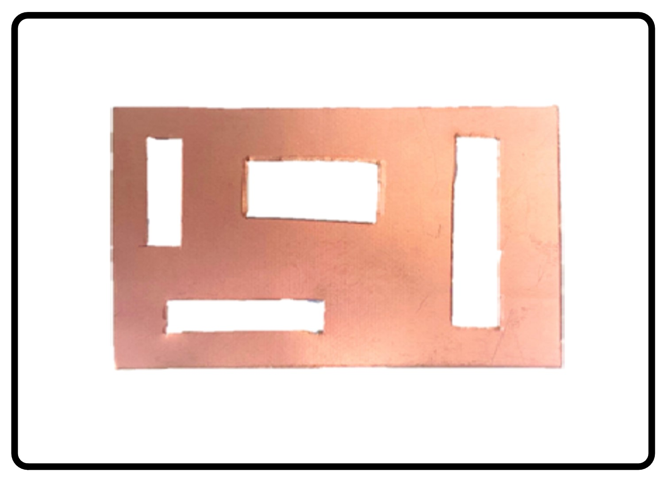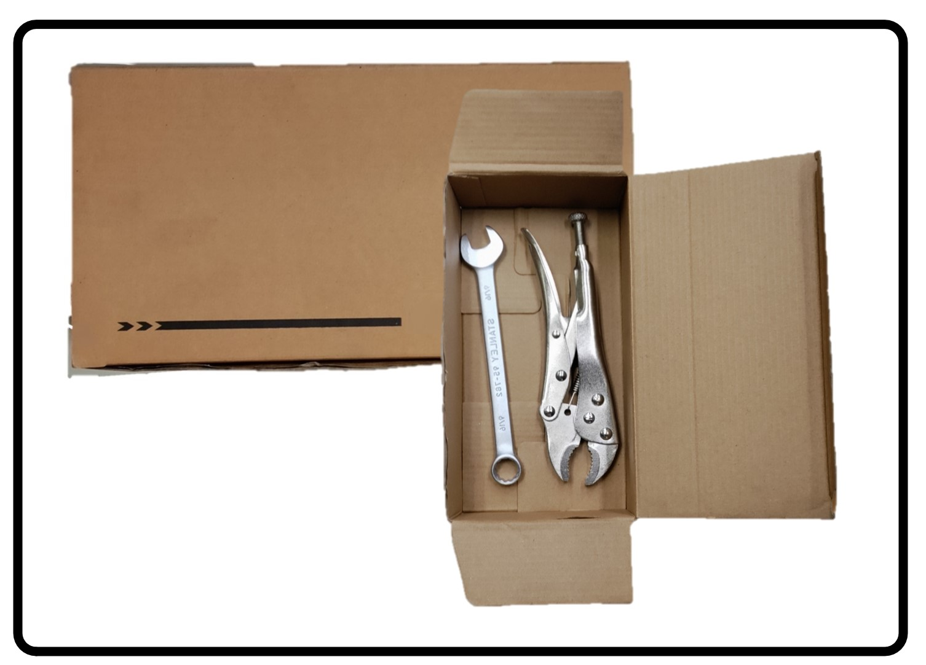

(a) (b)

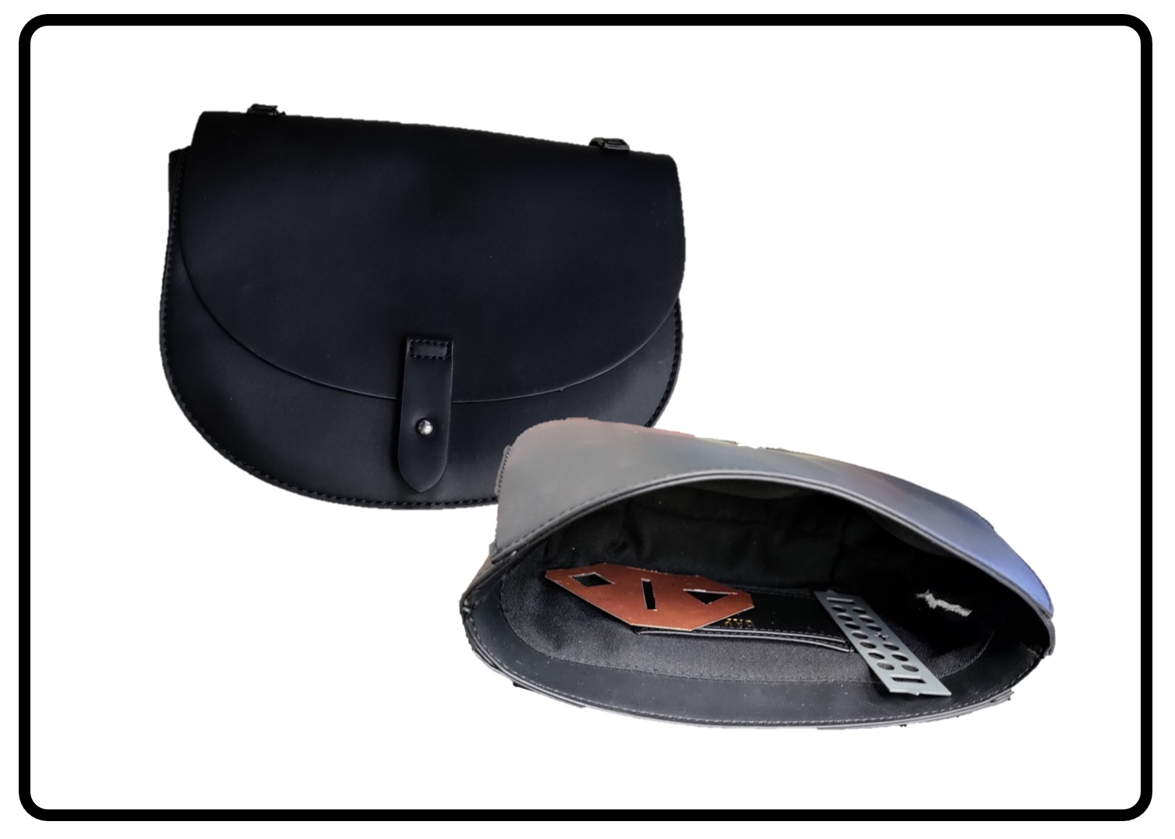

(c)

Figure 9: Various experimental targets: (a) copper clad laminate test target, (b) tools hidden inside box, and (c) purse containing metal cutouts.

The test target with several horizontal and vertical rectangular cutouts made from copper-clad laminate (Fig. 9a) is illuminated by the *x*-*y* scanner at the planes *z* ∈ [275*,*324] mm with a separation of 1 mm. Hence, data are collected throughout the same region discussed previously such that *x*′ ∈ [−12*.*5*,*12*.*5] cm, *y*′ ∈ [−12*.*5*,*12*.*5] cm, and *zℓ* ∈ [−2*.*5*,*2*.*5] cm with 102762 sampling locations. After the data were collected, the 50 planar scans were subsampled using a similar random 2-D curves as shown in Fig. 7 to emulate the multi-planar irregular sampling scenario. The imaging results and the corresponding computation times for each reconstruction algorithm are shown in Fig. 10. Our proposed multi-planar multistatic imaging technique demonstrates robustness in projecting the irregular scanning geometry to a planar scenario for more efficient image recovery as the cutout is recovered cleanly without significant artifacting, as shown in Fig. 10c. In contrast, the image recovered using the BPA requires nearly 30 minutes to compute, and although the RMA is computed efficiently, the RMA without multi-planar compensation is unable to resolve the target scene, as shown in Fig. 10b. Furthermore, when the target location is unknown in the *z*-direction, 3-D imaging offers an improved solution at a higher computational cost.

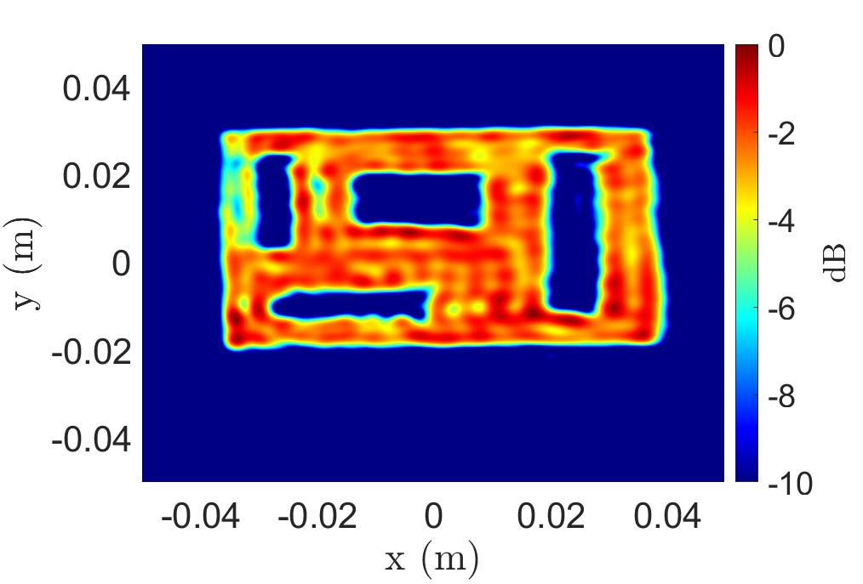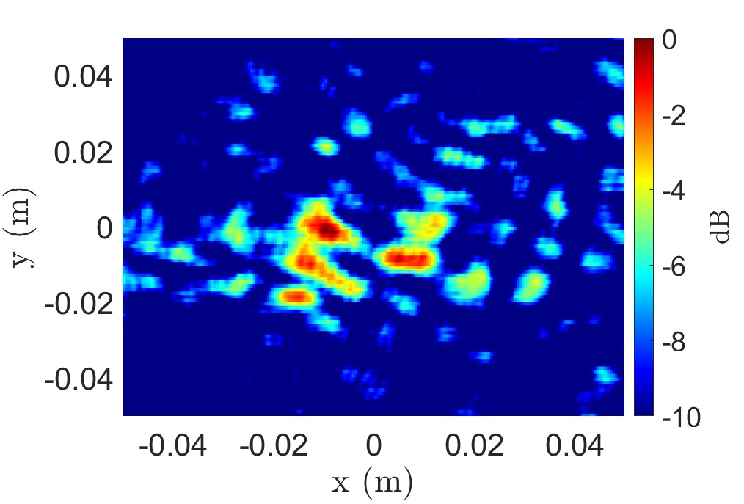

(a) (b)

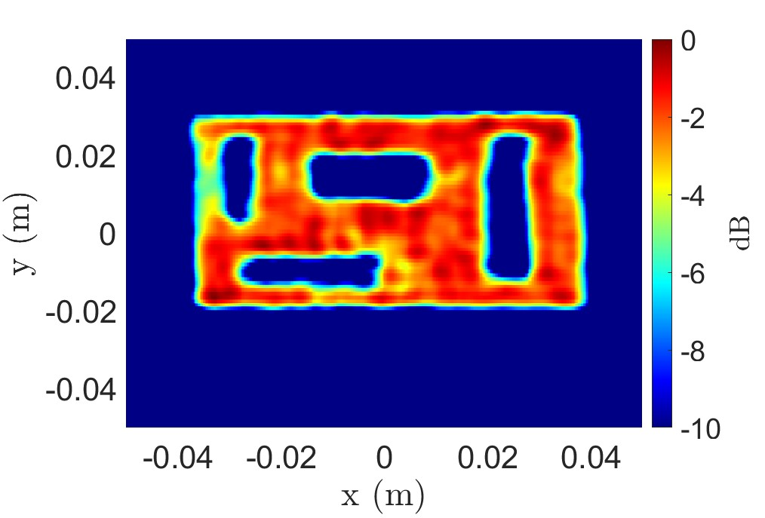

(c)

Figure 10: Imaging results for the copper test target using the (a) BPA (1324.8 s), (b) RMA without multi-planar multistatic compensation (1.1 s), and (c) proposed algorithm (1.1 s).

The second target screened by the prototype to demonstrate a hidden target scenario consists of two wrenches (a combination wrench and a vise grip) hidden inside a cardboard box, as shown in Fig. 9b. SAR scans of the target are performed with the target at the *z*-planes *z* ∈ [275*,*324] mm with a separation of 1 mm. To accommodate a larger target size, the aperture is increased to *x*′ ∈ [−25*,*25] cm, *y*′ ∈ [−25*,*25] cm, and *zℓ* ∈ [−2*.*5*,*2*.*5] cm with 102545 sampling locations. Similarly, the *x*-*y*-*z* data are sampled to emulate the multi-planar multi-static scenario using a semismooth random curve as shown in Fig. 7. The 2-D and 3-D implementations of the BPA and proposed algorithm are applied to the nonuniform data under the irregular scanning geometry, and the recovered images are shown in Figs. 11a – 11d. Both wrenches are visible in the reconstructed images; however, while the 2-D image from the BPA and proposed algorithm provide high-fidelity reconstructions of the hidden tools, the 2-D *z*-plane must be carefully selected to obtain such images. The presence and location of targets are generally unknown for concealed item detection problems such as this. Hence, 3-D imaging is preferable for such scenarios and is primarily constrained by computational expense. Our proposed algorithm offers an elegant compromise between the efficiency of the RMA and the image quality of the BPA. In Fig. 11d, the 3-D image is computed by the proposed algorithm with an image quality comparable to that of the BPA with significantly reduced computational cost.

A third experiment is conducted with several metal cutouts concealed in a purse to emulate a scenario wherein a suspicious personal item is quickly screened with an irregular scanning geometry, such as freehand SAR or drone imaging. Fig 9c shows the purse and two hidden items: one triangularly shaped metal plate with different cutout shapes and one rectangular metal plate with circular holes. The target is scanned by the multi-planar multistatic prototype discussed in Section IV, and the data are employed to emulate an irregular sampling scenario. Scans are performed with the target at the *z*-planes *z* ∈ [275*,*324] mm with a separation of 1 mm and an aperture is synthesized within *x*′ ∈ [−25*,*25] cm, *y*′ ∈ [−25*,*25] cm, and *zℓ* ∈ [−2*.*5*,*2*.*5] cm with 102821 sampling locations. The reconstructed images and the corresponding computation times are shown in Figs. 11e – 11h. Both metal cutouts are resolved using our algorithm with image quality comparable to that of the BPA. Again, assuming that the contents of the purse are generally unknown, computing the 3-D image is preferable for concealed item detection. To efficiently recover a 3-D image with irregularly sampled data, existing inversion techniques require excessive computation time and memory capacity, as shown in Figs. 11e and 11f. However, our proposed algorithm (Figs. 11g and 11h) offers an efficient solution that does not compromise image quality.

These experiments demonstrate the advantages of the proposed algorithm and the limitations of the RMA and BPA. A comparison of the required computation times for each algorithm is presented in Table 1. Applying the RMA directly to the multi-planar data, as shown in Figs. 6c, 8b, and 10b, yields significant aberrations to the point of failed reconstruction. For this reason, the RMA images are not shown for the other examples. When the target is known to be 2-D and located at a single, known *z*-plane, the 2-D BPA implementation can be computed somewhat efficiently in certain instances by employing a graphics processing unit (GPU) and parallelizing the computation [7], [10]–[13]. However, particularly for mobile applications, access to highcapacity GPUs is rare or size-prohibitive, and such acceleration is infeasible. Moreover, as the BPA is scaled up to three dimensions, the time and space complexities increase exponentially, requiring excessive computational power and memory. In many emerging applications, efficient 3-D image computation on low-power devices is preferable, if not mandatory, as the precise location of the target is generally unknown. However, efficient algorithms, such as the RMA, require monostatic, planar assumptions that are unachievable by these applications. To enable such technologies, our proposed multi-planar multistatic imaging algorithm efficiently compensates for the irregular scanning geometry by careful handling of the phase of each sample. This enables image reconstruction under dynamic conditions with identical computational complexity to the RMA and image quality comparable to that of the BPA.

Metal Cutout Hidden Tools Purse

|  |  |  |  |
| --- | --- | --- | --- |
| 2-D BPA | 1324.8 | 5299.4 | 5299.4 |
| 3-D BPA | 339159.2 | 1356636.9 | 1356636.9 |
| 2-D RMA | 1.1 | 4.3 | 4.3 |
| 3-D RMA | 4.8 | 10.7 | 10.7 |
| 2-D Proposed | 1.1 | 4.3 | 4.3 |
| 3-D Proposed | 4.8 | 10.7 | 10.7 |

Table 1: Computation time, in seconds, required by the various algorithms for each experiment.

## VI. CONCLUSION

In this article, we presented a novel approach for highresolution, efficient 3-D near-field SAR imaging for irregular scanning geometries. We proposed a multi-planar multistatic framework applicable to a diverse set of applications, including freehand imaging, UAV SAR, and automotive imaging. A novel algorithm is proposed to efficiently compensate irregularly sampled multi-planar multistatic data to equivalent planar monostatic mmWave radar data. Our technique extends the traditional RMA by presenting an algorithm for efficiently aligning multi-planar multistatic data to a virtual planar monostatic scenario. By projecting the data to a virtual planar monostatic equivalent array, this method extends the RMA to account for both irregular scanning and MIMOSAR effects resulting in high-fidelity focusing. The proposed algorithm is valid for common radar signaling techniques in 5G, IoT, smartphone, and automotive applications. Simulation results are presented demonstrating the robustness of our approach in the presence of significant deviation among samples along the *z*-direction. Furthermore, we empirically validated the proposed algorithm using a custom prototype to capture multi-planar multistatic data for several concealed and obscured scenarios. In both simulation and experimental studies, our algorithm achieves efficient image reconstruction matching the focusing quality of the existing techniques while reducing computational complexity by a considerable margin.

.

|  |
| --- |
| (a) (b) (c) (d)  (e) (f) (g) (h)  Figure 11: Imaging results for the hidden tools target, as shown in Fig. 9b, using the (a) 2-D BPA (5299.4 s), (b) 3-D BPA (1356636.9 s), (c) 2-D proposed algorithm (4.3 s), and (d) 3-D proposed algorithm (10.7 s). Imaging results for the concealed items in a purse, as shown in Fig. 9c, using the (e) 2-D BPA (5299.4 s), (f) 3-D BPA (1356636.9 s), (g) 2-D proposed algorithm |

(4.3 s), and (h) 3-D proposed algorithm (10.7 s).

### APPENDIX A MULTIVARIATE TAYLOR SERIES EXPANSION

Consider an infinitely differentiable real-valued function and an open neighborhood around (*u,v,w*) = (*u*0*,v*0*,w*0). Let **x** = [*u v w*]*T* and **x**0 = [*u*0 *v*0 *w*0]*T*. Hence, the multivariate Taylor series expansion of *f*(**x**) in the neighborhood of **x**0 can be written as

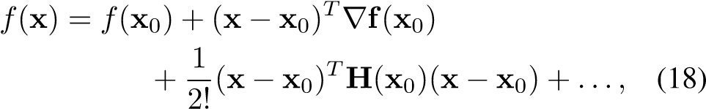

where ∇**f** is the vector of first derivatives

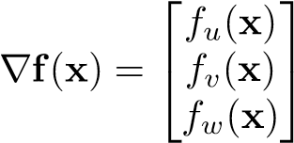 *,* (19)

and **H**(**x**) is the Hessian matrix of the second derivatives as

**H**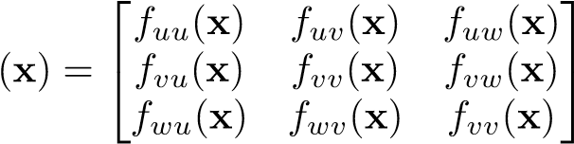 *.* (20)

# A. TAYLOR SERIES EXPANSION OF ROUND-TRIP DISTANCE FOR IRREGULAR SCANNING GEOMETRIES

The round-trip distance between the *ℓ*-th Tx/Rx pair, whose transmitter and receiver elements are located at (*xT,yT,zℓ*) and (*xR,yR,zℓ*), respectively, and the scatterer located at (*x,y,z*) is expressed in (2). Substituting (3) and (4) into (2), *RℓRT* can be expressed as a function of the distances between the Tx and Rx elements along the *x*- and *y*-directions, *dxℓ* and , respectively, and displacement along the *z*-direction, *dzℓ*:

*RℓRT*(*dxℓ ,dyℓ,dzℓ*)

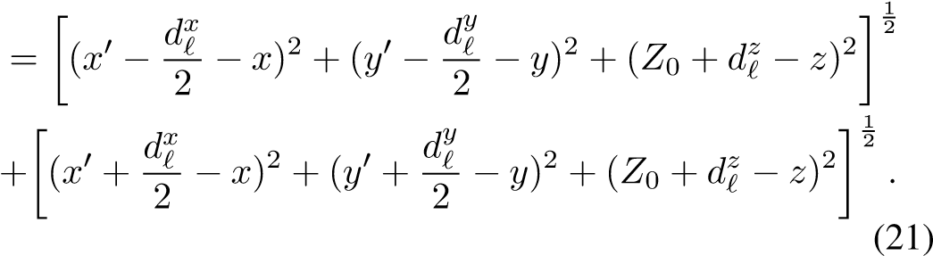

The first derivatives of (21), evaluated at *dxℓ* = *dyℓ* = *dzℓ* = 0, are

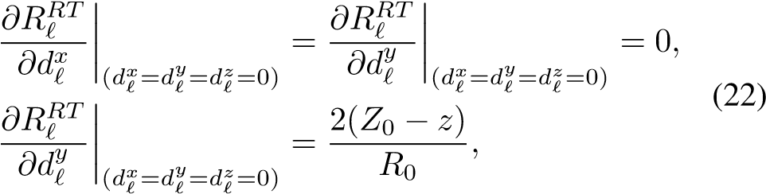

where *R*0 is the distance between the virtual monostatic element located at (*x*′*,y*′*,Z*0) and the point scatterer at (*x,y,z*), expressed in (6).

The second derivatives of (21), evaluated at the point of interest, can be derived as

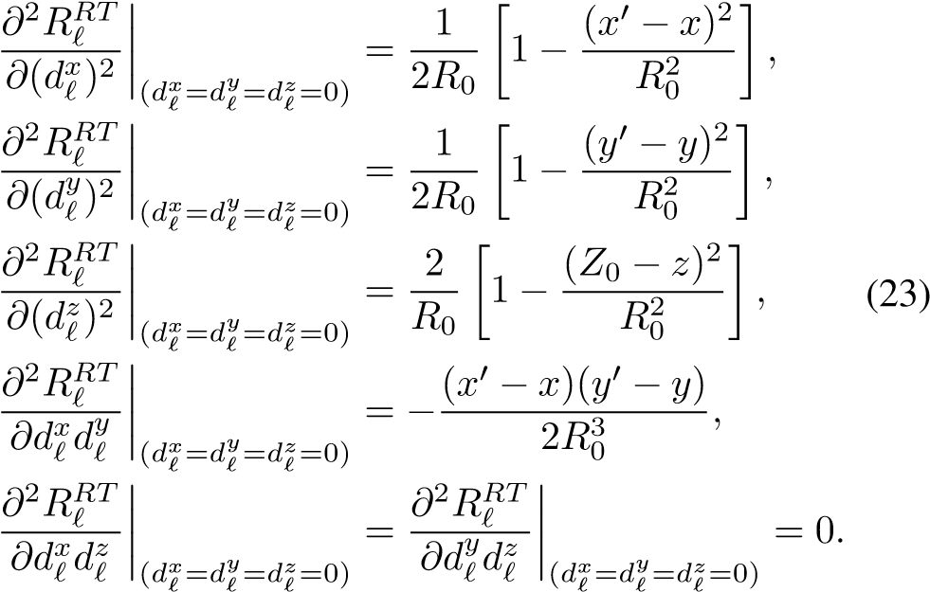

Substituting (22) and (23) into (18), the quadratic approximation of *Rℓ* can be expressed as

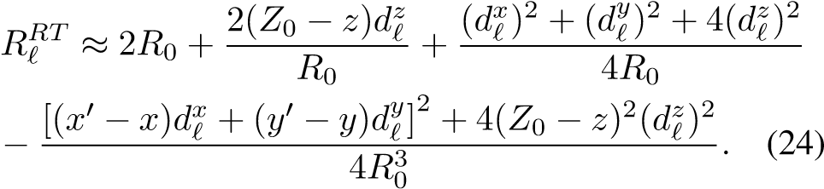

## References

1. J. W. Smith, S. Thiagarajan, R. Willis, Y. Makris, and M. Torlak, “Improved static hand gesture classification on deep convolutional neural networks using novel sterile training technique,” *IEEE Access*, vol. 9, pp. 10893–10902, Jan. 2021.
2. D. M. Sheen, T. E. Hall, D. L. McMakin, A. M. Jones, and J. R. Tedeschi, “Three-dimensional radar imaging techniques and systems for near-field applications,” in *Proc. SPIE 9829 Radar Sensor Techn. XX*, Baltimore, MD, USA, May 2016, pp. 230–241.
3. M. E. Yanik and M. Torlak, “Near-field 2-D SAR imaging by millimeter-wave radar for concealed item detection,” in *Proc. IEEE RWS*, Orlando, FL, USA, Jan. 2019, pp. 1–4.
4. L. Chao, M. N. Afsar, and K. A. Korolev, “Millimeter wave dielectric spectroscopy and breast cancer imaging,” in *Proc. IEEE EuMIC*, Amsterdam, Netherlands, Oct. 2012, pp. 572–575.
5. Y. Gao and R. Zoughi, “Millimeter wave reflectometry and imaging for noninvasive diagnosis of skin burn injuries,” *IEEE Trans. Instrum. Meas.*, vol. 66, no. 1, pp. 77–84, Nov. 2016.
6. O. Li, J. He, K. Zeng, *et al.*, “Integrated sensing and communication in 6G a prototype of high resolution THz sensing on portable device,” in *Proc. IEEE EuCNC/6G*, Porto, Portugal, Jun. 2021, pp. 544–549.
7. G. Álvarez-Narciandi, J. Laviada, and F. Las-Heras, “Towards turning smartphones into mmWave scanners,” *IEEE Access*, vol. 9, pp. 45147–45154, Mar. 2021.
8. K. Basrawi and R. Dill, “Reverse engineering the Soli radar API for military applications,” in *Proc. IEEE RadarConf21*, Jun. 2021, pp. 1–8.
9. J. W. Smith, O. Furxhi, and M. Torlak, “An FCNNbased super-resolution mmWave radar framework for contactless musical instrument interface,” *IEEE Trans. Multimedia*, pp. 1–1, May 2021.
10. G. Álvarez-Narciandi, M. López-Portugués, F. LasHeras, and J. Laviada, “Freehand, agile, and highresolution imaging with compact mm-Wave radar,” *IEEE Access*, vol. 7, pp. 95516–95526, Jul. 2019.
11. G. Álvarez-Narciandi, J. Laviada, and F. Las-Heras, “Freehand mm-Wave imaging with a compact MIMO radar,” *IEEE Trans. Antennas Propag.*, vol. 69, no. 2, pp. 1224–1229, Feb. 2021.
12. G. Álvarez-Narciandi, J. Laviada, Y. Álvarez-López, *et al.*, “Freehand system for antenna diagnosis based on amplitude-only data,” *IEEE Trans. Antennas Propag.*, vol. 69, no. 8, pp. 4988–4998, Feb. 2021.
13. H. F. Álvarez, G. ÁLvarez-Narciandi, F. Las-Heras, and J. Laviada, “System based on compact mmWave radar and natural body movement for assisting visually impaired people,” *IEEE Access*, vol. 9, pp. 125042– 125051, Sep. 2021.
14. H. Wymeersch, G. Seco-Granados, G. Destino, D. Dardari, and F. Tufvesson, “5G mmWave positioning for vehicular networks,” *IEEE Wireless Commun.*, vol. 24, no. 6, pp. 80–86, Dec. 2017.
15. Z. Hajiakhondi-Meybodi, M. Salimibeni, K. N. Plataniotis, and A. Mohammadi, “Bluetooth low energybased angle of arrival estimation via switch antenna array for indoor localization,” in *Proc. IEEE FUSION*, Rustenburg, South Africa, Jul. 2020, pp. 1–6.
16. J. W. Smith, M. E. Yanik, and M. Torlak, “Nearfield MIMO-ISAR millimeter-wave imaging,” in *Proc. IEEE RadarConf*, Florance, Italy, Sep. 2020, pp. 1–6.
17. M. E. Yanik and M. Torlak, “Near-field MIMO-SAR millimeter-wave imaging with sparsely sampled aperture data,” *IEEE Access*, vol. 7, pp. 31801–31819, Mar. 2019.
18. M. E. Yanik, D. Wang, and M. Torlak, “3-D MIMOSAR imaging using multi-chip cascaded millimeterwave sensors,” in *Proc. IEEE GlobalSIP*, Ottawa, ON, Canada, Nov. 2019, pp. 1–5.
19. J. M. Lopez-Sanchez and J. Fortuny-Guasch, “3D radar imaging using range migration techniques,” *IEEE Trans. Antennas Propag.*, vol. 48, no. 5, pp. 728– 737, May 2000.
20. M. E. Yanik, D. Wang, and M. Torlak, “Development and demonstration of MIMO-SAR mmWave imaging testbeds,” *IEEE Access*, vol. 8, pp. 126019–126038, Jul. 2020.
21. C. F. Baumgartner, K. Kamnitsas, J. Matthew, *et al.*, “SonoNet: Real-time detection and localisation of fetal standard scan planes in freehand ultrasound,” *IEEE Trans. Medical Imaging*, vol. 36, no. 11, pp. 2204– 2215, Jul. 2017.
22. J. Blackall, G. Penney, A. King, and D. Hawkes, “Alignment of sparse freehand 3-D ultrasound with preoperative images of the liver using models of respiratory motion and deformation,” *IEEE Trans. Medical Imaging*, vol. 24, no. 11, pp. 1405–1416, Oct. 2005.
23. M. W. Gilbertson and B. W. Anthony, “Force and position control system for freehand ultrasound,” *IEEE Trans. Robotics*, vol. 31, no. 4, pp. 835–849, Jun. 2015.
24. J. W. Smith and M. Torlak, “Terhertz imaging toolbox with interactive user interface,” *unpublished*, 2022.
25. X. Zeng, Y. Ma, Z. Li, J. Wu, and J. Yang, “A near-field fast time-frequency joint 3-D imaging algorithm based on aperture linearization,” in *Proc. IEEE IGARSS*, Brussels, Belgium, Oct. 2021, pp. 5163– 5166.
26. M. Garcia-Fernandez, Y. Alvarez-Lopez, and F. L. Heras, “3D-SAR processing of UAV-mounted GPR measurements: Dealing with non-uniform sampling,” in *Proc. IEEE EuCAP*, Copenhagen, Denmark, Aug. 2020, pp. 1–5.
27. B. Wu, G. Álvarez-Narciandi, and J. Laviada, “Multilayered circular dielectric structure SAR imaging using time-reversal compressed sensing algorithms based on nonuniform measurement,” *IEEE Antennas Wireless Propag. Lett.*, vol. 19, no. 9, pp. 1491–1495, Jul. 2020.
28. T. Kan, G. Xin, L. Xiaowei, and L. Zhongshan, “Implementation of real-time automotive SAR imaging,” in *Proc. IEEE SAM*, Hangzhou, China, Jun. 2020, pp. 1–4.
29. D. M. Sheen, D. L. McMakin, and T. E. Hall,

“Three-dimensional millimeter-wave imaging for concealed weapon detection,” *IEEE Trans. Microw. Theory Techn.*, vol. 49, no. 9, pp. 1581–1592, Sep. 2001.

1. J. Gao, Y. Qin, B. Deng, H. Wang, and X. Li, “Novel efficient 3D short-range imaging algorithms for a scanning 1D-MIMO array,” *IEEE Trans. Image Process.*, vol. 27, no. 7, pp. 3631–3643, Apr. 2018.
2. B. Fan, J. Gao, H. Li, Z. Jiang, and Y. He, “Nearfield 3D SAR imaging using a scanning linear MIMO array with arbitrary topologies,” *IEEE Access*, vol. 8, pp. 6782–6791, Dec. 2019.
3. J. Gao, B. Deng, Y. Qin, H. Wang, and X. Li, “Efficient terahertz wide-angle NUFFT-based inverse synthetic aperture imaging considering spherical wavefront,” *Sensors*, vol. 16, no. 12, p. 2120, Dec. 2016.
4. R. K. Amineh, N. K. Nikolova, and M. Ravan, *RealTime Three-Dimensional Imaging of Dielectric Bodies Using Microwave/Millimeter Wave Holography*. John Wiley & Sons, 2019.
5. J. H. G. Ender and J. Klare, “System architectures and algorithms for radar imaging by MIMO-SAR,” in *Proc. IEEE RadarConf*, Pasadena, CA, USA, May 2009, pp. 1–6.
6. F. Roos, J. Bechter, C. Knill, B. Schweizer, and C. Waldschmidt, “Radar sensors for autonomous driving: Modulation schemes and interference mitigation,”

*IEEE Microw. Mag.*, vol. 20, no. 9, pp. 58–72, Aug. 2019.

1. J. Wang, P. Aubry, and A. Yarovoy, “3-D shortrange imaging with irregular MIMO arrays using NUFFT-based range migration algorithm,” *IEEE Trans. Geosci. Remote Sens.*, vol. 58, no. 7, pp. 4730– 4742, Jan. 2020.
2. L. Greengard and J.-Y. Lee, “Accelerating the nonuniform fast Fourier transform,” *SIAM Rev.*, vol. 46, no. 3, pp. 443–454, Aug. 2006.
3. D. Sheen, D. McMakin, and T. Hall, “Near-field threedimensional radar imaging techniques and applications,” *Appl. Opt.*, vol. 49, no. 19, E83–E93, Jun. 2010.
4. T. Zhang and X.-G. Xia, “OFDM synthetic aperture radar imaging with sufficient cyclic prefix,” *IEEE Trans. Geosci. Remote Sens.*, vol. 53, no. 1, pp. 394– 404, Jan. 2015.

JOSIAH W. SMITH (S’18) was born in Denver, CO, USA in 1997. He received the B.S. degree (*summa cum laude*) in electrical engineering from The University of Texas at Dallas in 2019, where he is currently pursuing a Ph.D. degree in electrical engineering specializing in communications engineering. He was awarded the Texas Instruments Analog Excellence Graduate Fellowship in August 2019 and the Louis Beecherl, Jr. Graduate Research Fellowship in August 2021. During

the summer of 2020, he developed real-time human-computer interaction algorithms for mmWave radar with imec-USA. In the summer of 2021, he developed advanced deep learning and data-driven algorithms for user experience enhancement at Apple in the Display Technologies group. His current research interests include hybrid-learning algorithms, new regime radar imaging algorithm development, ultra-wideband radar imaging algorithms, terahertz radar, radar perception, computer vision, deep learning, millimeter-wave sensing, and phased array signal processing.

MURAT TORLAK (SM’04) received the M.S. and Ph.D. degrees in electrical engineering from The University of Texas at Austin, in 1995 and 1999, respectively. Since August 1999, he has been with the Department of Electrical and Computer Engineering, The University of Texas, where he has been promoted to the rank of a Full Professor. He is serving as a Rotating Program Director at the U.S. National Science Foundation (NSF).

His current research interests include experimental

verification of wireless networking systems, cognitive radios, millimeterwave automotive radars, millimeter-wave imaging systems, and interference mitigation in radio telescopes. He was the General Chair of Symposium on Millimeter Wave Imaging and Communications in the 2013 IEEE GlobalSIP Conference. He has served as an Associate Editor for the IEEE Transactions on Wireless Communications, from 2008 to 2013. He is a Guest co-Editor of IEEE JSTSP Special Issue on Recent Advances in Automotive Radar Signal Processing, 2021.

Dear Dr. Gerardo Di Martino,

Please find attached our manuscript titled “Efficient 3-D Near-Field MIMO-SAR Imaging for Irregular Scanning Geometries,” which we would like to submit for publication as an original research article in your journal, *IEEE Access*. Our main contribution is an efficient algorithm for high-resolution near-field MIMO-SAR under irregular SAR geometries. Our analysis employs a novel approach to irregular SAR geometries in the near-field to project irregular multistatic synthetic arrays to virtual planar monostatic arrays. For many applications, e.g., drone imaging, freehand imaging, automotive SAR, etc., computational tractable algorithms for required for SAR imaging on irregular scanning geometries. Our novel algorithm offers an efficient solution to near-field irregular MIMO-SAR. This work has not been submitted elsewhere. Our recent submission with ID Access-2021-38447, was not recommended for publication and we have taken the necessary steps to rectify issues in our paper and comprehensively address the reviewers’ concerns. We have attached a document containing our responses to the reviewers’ comments on our previous submission with noted changes to our manuscript, an updated manuscript with individual changes highlighted, and a clean copy of our final manuscript.

We are looking forward to hearing from you.

Sincerely,

J. W. Smith and M. Torlak

**Original Manuscript ID:** Access-2021-38447

**Original Article Title:** “Efficient 3-D Near-Field MIMO-SAR Imaging for Irregular Scanning Geometries”

**To:** IEEE Access Editor

**Re:** Response to reviewers

Dear Dr. Gerardo Di Martino,

Thank you for allowing a resubmission of our manuscript, with an opportunity to address the reviewers’ comments.

We are uploading (a) our point-by-point response to the comments (below) (response to reviewers), (b) an updated manuscript with yellow highlighting indicating changes, and (c) a clean updated manuscript without highlights (PDF main document).

Best regards,

J. W. Smith and M. Torlak

**Reviewer #1, Concern #1:** The authors said the proposed method ‘enables such mobile and internet of things (IoT) applications through efficient image reconstruction.’ However, the 5G and IoT signals are usually modulated into an orthogonal frequency division multiplexing (OFDM) form, while the experiments reveal that the LFM signals are employed in this manuscript. Can you explain this?

**Author response:** The authors are grateful for the comments and suggestions of reviewer #1. Due to the diversity of modulation schemes, the signal model presented in Section II-C provides a generalized model to accommodate both OFDM and LFM radar, both of which are found in smartphone and IoT hardware. The reviewer is correct that it is a common practice for 5G and IoT signaling to employ orthogonal frequency division multiplexing (OFDM) as opposed to linear frequency modulation (LFM) or frequency modulated continuous wave (FMCW), which is common to automotive radar. Furthermore, the proposed algorithm, discussed in Sections II and III, is applicable for both OFDM and LFM signaling schemes, as clarified in the updated version of the manuscript. Additionally, we have included further references for the reader detailing OFDM radar for ranging and synthetic aperture (SAR) imaging. On the other hand, FMCW (LFM) modulation has been employed previously for smartphone applications to achieve radar sensing in the Google Pixel 4 with Google Soli radar and is commonly used for sensing exclusively in IoT applications. Prior work on smartphone SAR and similar applications has employed a purely LFM, stepped frequency signal model [10]-[13]. For these reasons, the signal model in Section II is generalized for any UWB modulation scheme and the proposed algorithm is applicable for both LFM and OFDM modulation schemes.

The authors appreciate the reviewer’s suggestion and have made changes to provide a clear explanation for the audience.

**Author action:** We updated the manuscript by the following actions:

1. In Section II-C, we added the following sentence to clarify the validity of the generalized signal model for common ultrawideband (UWB) modulation schemes.

“The frequency-domain model of the received signal (9) is valid for any UWB radar signaling scheme, including frequency-modulated continuous-wave (FMCW), phase modulated continuous wave (PMCW), or orthogonal frequency-division multiplexing (OFDM), commonly employed in 5G and IoT applications [35]. Further, prior research on freehand imaging and similar IoT applications has employed a purely stepped-frequency, FMCW signal model [10]-[13]. Similarly, the Google Pixel 4 utilizes a Google Soli 60 GHz mmWave FMCW radar for sensing [8].”

1. In Section IV, we clarified the choice of an FMCW radar and the efficacy of the proposed algorithm for both OFDM and FMCW radar signaling by adding the following part.

“While 5G and IoT applications commonly employ an OFDM modulation scheme, the TI radar employed for the following experiments is limited to FMCW signaling. On the other hand, FMCW radar has been utilized for smartphone applications, notably the Google Pixel 4, which is equipped with a Google Soli FMCW radar [8]. The proposed range migration-based algorithm is applicable to both OFDM and FMCW radars; hence, the results discussed in the following section are relevant for a wide array of 5G, IoT, smartphone, and automotive applications [39].”



**Reviewer #1, Concern #2:** It seems that the Tx and Rx are fixed in the board and have the same movement state, since the TI AWR1443BOOST is used in the experiments. Does it meet the requirements for irregular sampling in real scene?

**Author response:** The authors appreciate this comment from the reviewer. The reviewer is correct that the transmit (Tx) and receive (Rx) elements are fixed on the radar board in the experiments. However, the number of elements on the board are small such that the radar is suitable for a smartphone or IoT application. The challenge is to synthetically create a uniform aperture geometry. Existing techniques for image reconstruction with non-cooperative near-field scanning geometries are computationally burdensome and infeasible for mobile applications. The irregular scanning geometry investigated in this manuscript, referred to as multi-planar multistatic, is an extension of the common planar MIMO-SAR scanning mode. In planar MIMO-SAR, a multistatic radar platform is scanned across a planar aperture, implying the Tx and Rx elements are fixed to the board and spatially translated as the radar is scanned across the planar track. The algorithm proposed in our manuscript offers an efficient solution to the MIMO-SAR case such that the planar assumption does not hold. For applications such as smartphone freehand imaging or automotive SAR, the MIMO radar is scanned across space, but the planar array assumption is invalid. For the multi-planar MIMO-SAR scanning mode, described in Section II-A and shown in Fig. 1, the Tx and Rx are fixed on the radar and the entire radar platform is moved throughout space in an irregular scanning pattern. Hence, the TI AWR1443BOOST used in the experiments does meet the irregular sampling conditions investigated in this manuscript.

To provide further clarity to the reader, we have added additional detail to Section II-A explaining the multi-planar MIMO-SAR operation and potential applications.

**Author action:** We updated the manuscript by adding the following paragraph to Section II-A:

“Compared to planar MIMO-SAR, which requires a multistatic MIMO array to be scanned across a planar track [17], [20], [31], multi-planar MIMO-SAR allows the multistatic array to be scanned across 3-D space. For freehand imaging or automotive SAR, a MIMO array is fixed to the smartphone or vehicle, respectively, and is moved throughout space generating a multi-planar MIMO-SAR irregular aperture. As shown in Fig. 1, as the multistatic array is scanned in an irregular pattern spanning multiple *z*-planes, the locations of the transmit (Tx) and receive (Rx) elements are spatially translated by the movement of the MIMO array. The analyses in the subsequent sections present an efficient solution to irregular MIMO-SAR imaging such that the position of the radar is known throughout the scan and the planar array assumption does not hold. This scenario is common for many of the aforementioned applications, which necessitate both irregular scanning geometries and efficient image recovery.”



**Reviewer #1, Concern #3:** The sampling rates, i.e., pulse repetition frequency (PRF) and sampling rate in base band, should be analyzed to avoid the undersampled case.

**Author response:** The authors agree with the reviewer’s comment and have included a more detailed analysis on spatial sampling rates to avoid undersampling. The spatial and sampling, dictated by the pulse petition frequency (PRF), and baseband sampling rate are both relevant factors in system design and implementation and have been explored more thoroughly in the update manuscript.

**Author action:** We updated the manuscript by making the highlighted change to the following excerpt from Section III:

“Sampling considerations for image reconstruction remain identical to those in analyses elsewhere [17], [29] after the multi-planar compensation algorithm. Baseband frequency sampling criteria can be determined by the maximum range for a given application. As given in [38], the maximum frequency sampling interval is given by $Δf<c/(2R_{max})$, where $R_{max}$ is the maximum target range. While spatial sampling criteria are not guaranteed for irregular SAR scanning if the relationship between the capture rate of the radar and the velocity of the radar platform is tuned appropriately during system design, undersampling artifacts are minimal in most cases [10]-[13]. To avoid spatial undersampling, the lower bound of the pulse repetition frequency (PRF) can be computed by PRF $>4v_{max}/λ_{c}$, where $v_{max}$ is the maximum velocity for a certain application. For example, assuming the maximum velocity of a human hand for a freehand SAR is 1 m/s and a center frequency of 79 GHz, the lower bound of the PRF is approximately 1.06 kHz. It is important to note that the number of captures increases proportionally to the PRF; hence, at high velocities, a large number of samples will be captured. Computational performance of traditional techniques, employing the BPA, degrades substantially when many samples are captured. On the other hand, signal-to-noise ratio can be improved by increasing the number of samples, at the cost of increased computational burden. Hence, an efficient algorithm for multi-planar MIMO-SAR imaging is required to enable many such technologies.”



**Reviewer #1, Concern #4:** It is a good work to analysis the 3D resolutions in Eq.(17). Why not validate these resolutions in the experiments part?

**Author response:** This comment, in addition to concern #3 of reviewer #2, is an excellent suggestion to bolster the robustness of this study. We have revised the manuscript to include an investigation of the spatial resolution and the impact of the extent of the sampling irregularity on the imaging resolution. The resolution of the proposed algorithm is compared against the ideal, planar RMA image reconstruction algorithm with varying degrees of array perturbation.

**Author action:** We updated the manuscript by including a thorough study on the impact of sampling irregularity on image resolution by considering the point spread function (PSF) for several non-cooperative scanning geometries. Each PSF is simulated with a different value for $Δ_{z}^{max}≜\max{{|d}_{l}^{z}|}$, the maximum distance between the reference plane, $Z_{0}$, and the samples, as defined in Section II-B. The simulated PSFs are compared against the PSF from an ideal planar scenario using the traditional RMA. As the value of $Δ_{z}^{max}$ is increased and the synthetic array is increasingly nonplanar, the resolution of the main lobe along the ­­*y*- and *z*-directions degrades marginally and inferior sidelobe suppression is observed. However, even with significant perturbations in the array geometry, in the proposed algorithm achieves quite similar resolution to the RMA under ideal conditions. Prior work on freehand smartphone imaging system design and implementation has assumed deviations on the order of 1 cm [7]. The results are detailed in the updated manuscript in Section V-A and shown in Fig. 5. Further detail and explanation are given for Reviewer #2, Concern #3.



**Reviewer #1, Concern #5:** It appears that the RM algorithm is adopted in case of 3D non-cooperative SAR imaging, in this manuscript. Can you explain the difference between traditional RM algorithm and your proposed RM algorithm?

**Author response:** The authors appreciate this comment from reviewer #1. The proposed range migration (RM) algorithm is an adapted version of the traditional RM algorithm for 3-D non-cooperative MIMO-SAR in the near-field. The proposed algorithm solves both the multi-planar (irregular) sampling problem and the MIMO-SAR problem efficiently by aligning the multi-planar multistatic data to virtual planar monostatic data for efficient image reconstruction. The multi-planar multistatic to planar monostatic projection is the main difference between the proposed RM algorithm and the conventional RM algorithm. This crucial step compensates for both the sampling irregularities and multistatic MIMO effects simultaneously, while reducing dimensionality and computational complexity significantly. The manuscript has been updated to explicitly detail the novelty of the proposed algorithm.

**Author action:** We updated the manuscript by the following actions:

1. In Section I, we clarified the distinction between the traditional RMA and our proposed algorithm by including the following highlighted portion to this paragraph.

“In this article, we propose a novel image reconstruction technique for efficient near-field imaging with irregular scanning geometries, such as those present in freehand imaging, UAV SAR, or automotive scenarios. We examine the system and signal models for UWB MIMO-SAR and develop a multi-planar multistatic approach to mathematically decompose the irregularly sampled synthetic array such that an equivalent virtual planar monostatic array can be constructed. This technique is the first to extend the range migration algorithm (RMA) such that non-cooperative SAR scanning and multistatic effects are simultaneously mitigated. The analysis in the subsequent sections provides a novel framework through which to decompose irregular SAR scenarios and efficiently project the irregular MIMO-SAR samples to a virtual planar monostatic equivalent. The proposed algorithm is validated through simulation and experimentation, demonstrating robustness to arbitrary scanning patterns and offering low computational complexity. Our solution enables emerging technologies that require non-ideal SAR scanning geometries, MIMO multistatic radar, and efficient image reconstruction.”

1. In Section III, we added the following details to further address the novelty developed in this study.

“The key difference between the traditional RMA and the proposed algorithm is the aligning of the multi-planar multistatic (MIMO-SAR) data to virtual planar monostatic data. This crucial step compensates for both the sampling irregularities and multistatic MIMO effects simultaneously, while significantly reducing the dimensionality, from 6-D $\left(x_{T},x_{R},y_{T},y_{R},z_{l},f\right)$ to 3-D $\left(x^{'},y^{'},f\right)$, and subsequently the computational complexity.”

1. In Section VI, we included the highlighted portion below to provide a thorough discussion of the novel extension of our technique to the conventional RMA.

In this article, we presented a novel approach for high-resolution, efficient 3-D near-field SAR imaging for irregular scanning geometries. We proposed a multi-planar multistatic framework applicable to a diverse set of applications, including freehand imaging, UAV SAR, and automotive imaging. A novel algorithm is proposed to efficiently compensate irregularly sampled multi-planar multistatic data to equivalent planar monostatic mmWave radar data. Our technique extends the traditional RMA by presenting an algorithm for efficiently aligning multi-planar multistatic data to a virtual planar monostatic scenario. By projecting the data to a virtual planar monostatic equivalent array, this method extends the RMA to account for both irregular scanning and MIMO-SAR effects resulting in high-fidelity focusing. The proposed algorithm is valid for common radar signaling techniques in 5G, IoT, smartphone, and automotive applications. Simulation results are presented demonstrating the robustness of our approach in the presence of significant deviation among samples along the *z*-direction. Furthermore, we empirically validated the proposed algorithm using a custom prototype to capture multi-planar multistatic data for several concealed and obscured scenarios. In both simulation and experimental studies, our algorithm achieves efficient image reconstruction matching the focusing quality of the existing techniques while reducing computational complexity by a considerable margin.



**Reviewer #2, Concern #1:** The authors should include the number of considered samples used to compute each of the electromagnetic images.

**Author response:** The authors would like to thank the reviewer for their comments and concerns. We agree with the reviewer’s suggestion and have updated the manuscript to include the number of samples for each electromagnetic (EM) image.

**Author action:** We updated the manuscript to include the number of samples for both the simulated and empirical EM images in Section V.



**Reviewer #2, Concern #2:** The size of the images of Figures 11b, 11d, 12b and 12d could be increased for a better readability.

**Author response:** The reviewer makes a good point that the clarity and readability of Figs. 11b, 11d, 12b, and 12d can be improved. We have merged Figs. 11 and 12 into a single figure covering both columns and increased the size of the 3-D figures mentioned by the reviewer.

**Author action:** We updated the manuscript by combining Figs. 11 and 12 into a single figure and increased the size of the figures as per the reviewer’s suggestion.



**Reviewer #2, Concern #3:** How far in the z direction can the samples be from the plane Z0? It seems that if sampling is smooth samples can be acquired at a large distance from the plane Z0.

**Author response:** The authors appreciate the reviewer’s suggestion and agree that the manuscript can be improved by the addition of a detailed study into the resolution limitations of the proposed algorithm with increasingly irregular arrays. The authors have modified the manuscript to include an investigation of the impact of the distance between the samples, $z_{l}$, and the $Z_{0}$ plane on image resolution. Section V-A and Fig. 5 provide the results and discussion of the resolution of the proposed algorithm as the array is degraded by perturbations and is increasingly non-linear or non-planar. The proposed algorithm achieves nearly identical main-lobe resolution at the cost of increased sidelobes as the array geometry is increasingly non-ideal.

**Author action:** We updated the manuscript by adding a paragraph to Section V-A and figure detailing a study of the spatial resolution of our algorithm compared to the resolution of the planar RMA in an ideal planar scanning scenario. Fig. 5 shows the range and cross-range point spread function (PSF) using the proposed algorithm with various irregular arrays of increasing $Δ_{z}^{max}≜\max{{|d}_{l}^{z}|}$, the maximum value of $d_{l}^{z}$, the distance between the samples and the reference plane $Z_{0}$. The PSF results demonstrate the focusing performance of the proposed algorithm compared to the traditional RMA and the main lobe beamwidth as $Δ_{z}^{max}$ increases, or the samples are taken farther from the reference plane. The system designed and implemented in [7] for freehand smartphone imaging assumes deviations on the order of 1 cm and our algorithm achieves comparable resolution to the ideal planar case with much larger values of $Δ_{z}^{max}$. The results in Fig. 5 provide further insight to the reader into the efficacy and limitations of the proposed algorithm. Further detail and explanation are given for Reviewer #1, Concern #4.



**Reviewer #2, Concern #4:** In column 1 of page 4 it seems that “is” is missing after “instantaneous wavenumber”.

**Author response:** The authors appreciate the careful reading of the reviewer and concur that this portion of the manuscript must be improved. We have implemented the suggested change in the updated manuscript.

**Author action:** We updated the manuscript by incorporating the change suggested by the reviewer in the following sentence:

“. . . where $k=2πf/c$ is the instantaneous wavenumber and $P\left(f\right)$ is the Fourier transform of $p(t)$.”



**Reviewer #2, Concern #5:** Can you include a link to a preprint/pre-release of [22]?

**Author response:** The authors will gladly share the preprint copy of the reference requested by the reviewer, [22] in the previous manuscript and [24] in the updated manuscript. The preprint document is attached as “Supplemental Material not for Review and not for Publication” in the new submission.

**Author action:** We included the requested preprint document as “Supplemental Material not for Review and not for Publication” in the new submission.



Efficient 3-D Near-Field SAR Imaging for Irregular Scanning Geometries

In this article, we introduce a novel algorithm for efficient near-field synthetic aperture radar (SAR) imaging for irregular scanning geometries. With the emergence of fifth-generation (5G) millimeter wave (mmWave) devices, near-field SAR imaging is no longer confined to laboratory environments. Recent advances in positioning technology have attracted significant interest in a diverse set of new applications for mmWave imaging. However, many use cases such as automotive-mounted SAR imaging, unmanned aerial vehicle (UAV) imaging, and freehand imaging with smartphones are constrained to irregular scanning geometries. Whereas traditional near-field SAR imaging systems and quick personnel security (QPS) scanners employ highly precise motion controllers to create ideal synthetic arrays, emerging applications, mentioned previously, inherently cannot achieve such ideal positioning. Additionally, many Internet of Things (IoT) and 5G applications impose strict size and computational complexity limitations that must be considered for edge mmWave imaging technology. In this article, we propose a novel algorithm to leverage the advantages of non-cooperative SAR scanning patterns, small form-factor multiple-input multiple-output (MIMO) radars, and efficient monostatic planar image reconstruction algorithms. We propose a framework to mathematically decompose arbitrary and irregular sampling geometries and a joint solution to mitigate multistatic array imaging artifacts. The proposed algorithm is validated in simulation and through an empirical study of arbitrary scanning scenarios. Our algorithm achieves high-resolution and high-efficiency near-field MIMO-SAR imaging and is an elegant solution to computationally constrained irregularly sampled imaging problems.

**IEEE Access Questions:**

Q: Please add a brief explanation justifying the manuscript type you have chosen. This information will help the Associate Editor and the reviewers during peer review so they evaluate your manuscript with the correct article type in mind.

A:

Our manuscript promotes a novel approach to multiple-input-multiple-output synthetic aperture radar (MIMO-SAR) in the near-field for irregular scanning geometries. In our article, we examine the existing work on similar problems, develop a new model for decomposing irregular SAR sampling, and propose a novel efficient algorithm to recover high resolution images from dynamic scenarios. Our algorithm is validated in both simulation and empirical study and compared against the existing techniques proving to yield highly resolved images with low computational complexity.

Q: Please describe how your article fits the scope of IEEE Access. Note, the scope of IEEE Access covers all (but only) IEEE’s fields of interest.

A:

Our manuscript explores novel areas of interest and recent publication within IEEE Access on synthetic aperture radar (SAR) for freehand imaging, irregular scanning geometries, and near-field imaging algorithms and systems. In our article, we pioneer an efficient algorithm for imaging on emerging near-field imaging modalities, e.g., drone imaging, freehand imaging, automotive SAR, etc. Our proposed algorithm is applicable to many 5G and IoT applications in addition to smartphone and automotive SAR imaging.

Q: Please state the unique contributions and advancements your article makes in the related existing literature.

A:

Our manuscript advances near-field synthetic aperture radar (SAR) imaging techniques by offering a joint solution to irregular sampling geometries and multistatic effects to improve computational complexity over previous techniques. We develop a novel framework to understand and decompose many irregular sampling problems such that a compensation algorithm can be applied to project irregular arrays to virtual regular arrays for efficient image computation. Whereas recent works have promoted system level designs sub-wavelength localization for irregular near-field SAR, our efficient algorithm enables such mobile and internet of things (IoT) applications through efficient image reconstruction.